Handwritten Digit Recognition with TensorFlow
A Complete Guide to the Tools, Features, Principles and Uses
Written for Level 3 learners
No prior machine learning knowledge needed
github.com/tjsuk/HandwrittenTensorflow
Based on README.md and handwritten_digit_recognition.ipynb (40 cells), as updated

Contents
Contents 2
1. How to use this guide 6
1.1 What this guide is for 6
1.2 Features that help you read it 6
1.3 What you already need to know 6
1.4 A quick decoder for the jargon 6
Model 6
Parameter 6
Hyperparameter 7
Training, inference, and the difference 7
Architecture 7
Feature 7
Deep 7
Overfitting 7
1.5 Suggested reading order 7
2. What the project is 8
2.1 The idea in one paragraph 8
2.2 Why it is written the way it is 8
2.3 What the project does not do 8
2.4 The files in the project 8
2.5 The twelve steps 9
3. Tools and setup 10
3.1 The tools the project uses 10
3.2 Installing and running the project 10
3.3 Why a virtual environment is used 11
3.4 Why the last command uses a full path 11
3.5 If something goes wrong 11
4. The problem being solved 13
4.1 What the computer actually receives 13
4.2 Why you cannot just write the rules 13
4.3 Turning the problem around 13
4.4 What kind of problem this is 14
5. Why TensorFlow is used 15
5.1 The job TensorFlow does 15
5.2 The six things TensorFlow gives this project 15
5.3 TensorFlow and Keras 15
5.4 What a tensor is 16
5.5 What hardware it runs on 16
5.6 Where a trained model can end up 16
6. The data: MNIST 17
6.1 What is in it 17
6.2 Why the data is split in two 17
6.3 Looking at the data first 17
6.4 Three things about MNIST that matter later 17
6.5 What MNIST is not 18
7. Preparing the data 19
7.1 What a pixel is here 19
7.2 Normalisation 19
Why it helps 19
Do it the same way every time 19
7.3 Flattening, and what it costs 19
7.4 The shape at each stage 19
8. How the neural network works 21
8.1 The word neural 21
8.2 What one neuron does 21
Weights 22
Bias 22
8.3 Activation functions, and why they are needed 22
Why relu 23
8.4 The input layer 23
8.5 The hidden layer 23
What it is for 23
Why 128 neurons 23
8.6 Dropout 24
8.7 The output layer 24
What softmax does 24
8.8 Counting the learned numbers 25
8.9 Following one image all the way through 25
8.10 Designing your own network 27
Step 1: work out what is forced 27
Step 2: follow the conventions 27
Step 3: make the choices that are actually yours 27
How many hidden layers 28
How wide each layer should be 28
How much dropout 28
Step 4: build the smallest thing that could work, then grow it 28
A worked example: designing for a different problem 28
Mistakes that catch everyone at least once 29
9. Setting up the learning 30
9.1 The optimizer 30
What adam adds 30
9.2 The loss 30
How this loss behaves 31
Why the word sparse 31
10. Training the model 32
10.1 What happens inside 32
10.2 Batches and epochs 32
Why not just do one image at a time? 33
10.3 Epochs in detail, and the point where more becomes worse 33
What one epoch actually is 33
What happens across the epochs 33
The critical point 33
Why more training makes it worse 34
How to find the critical point 34
Why this project uses 5 35
Epochs are not the only dial 35
10.4 Reading the training output 35
11. Testing the model 37
11.1 What 97 to 98 percent actually means 37
Why six digits changes everything 37
11.2 Overfitting and underfitting 37
11.3 If your accuracy looks low 38
11.4 What one accuracy number hides 38
12. Making predictions 40
12.1 Reading the ten numbers 40
12.2 The three ways the project shows results 40
13. The drawing canvas 41
13.1 How the canvas is built 41
13.2 Turning a drawing into something the model can read 41
13.3 The most useful lesson in the project 42
13.4 Teaching the model when it is wrong 42
Why it works 42
Why you should not trust it 42
14. Saving the trained model 44
14.1 File formats 44
15. Bonus: watching backpropagation happen 45
15.1 What a gradient actually is 45
15.2 Recording the sum so you can run it backwards 45
15.3 The toy example, and checking it by hand 46
15.4 The same thing on the real model 46
15.5 The zero gradients, and why they are not a bug 46
15.6 Applying one real update 47
15.7 Why this section is worth your time 47
16. A better design: convolutional networks 48
16.1 The problem being fixed 48
16.2 What a convolution does 48
16.3 What pooling does 48
16.4 The bonus model 48
16.5 Following the sizes through 49
16.6 Comparing the two models 49
17. Where this is used in the real world 51
17.1 Jobs this leads directly to 51
17.2 The step this project does not take 51
17.3 The same recipe elsewhere 51
17.4 When not to use a neural network 52
18. Limitations and risks 53
18.1 It cannot say 'I do not know' 53
18.2 Confidence is not the same as being right 53
18.3 The world changes and the model does not notice 53
18.4 There is no validation set 53
18.5 Data and privacy 53
19. Things to try 54
20. Test yourself 55
21. Glossary 57
22. Quick reference 59
22.1 Commands 59
22.2 The code used in the project 59
Getting the data 59
Describing the network 59
Checking what you built 60
Setting up and running training 60
Using the trained model 60
Looking inside training 60
Saving and loading 61
22.3 The numbers to remember 61
23. Where this information came from 61
23.1 What has been added 62

1. How to use this guide

1.1 What this guide is for
This guide explains a real coding project that teaches a computer to read handwritten numbers. The project is a Jupyter notebook. It uses a tool called TensorFlow to build something called a neural network.
The guide does two things. First, it lists every tool and feature the project uses, and explains what each one is for. Second, it explains the ideas behind those tools, so you understand why the project is built the way it is.
You should not need any other source. Every new word is explained the first time it appears, and there is a full glossary at the end.

1.2 Features that help you read it
Four kinds of box appear throughout the guide.
Key words in this section
A blue box like this lists the key words for a section before you start reading it.
Read it first, then read the section. Do not worry if the words mean nothing yet.
In short
A green box like this sums up the section in one or two sentences.
If you only remember one thing from a section, remember what is in the green box.
Check you understood
A purple box like this gives you questions to test yourself.
The answers are in the section you have just read.
An amber box gives instructions for rebuilding a diagram in another tool. You can skip these unless you need to redraw the diagrams yourself.

1.3 What you already need to know
- You can read basic Python code. You know what a variable, a list and a function are.
- You have used a Jupyter notebook, or you are happy to be shown.
- You can open a terminal and type a command.
- You do not need to know any machine learning. You do not need any maths beyond multiplying, adding and dividing.

1.4 A quick decoder for the jargon
Machine learning has a habit of giving ordinary ideas frightening names. Before you start, here are the ones that trip people up most, explained properly rather than in one line. Come back to this page whenever a word stops making sense.

Model
A model is just a big pile of numbers plus the instructions for how to use them. That is genuinely all it is. When people say "we trained a model", they mean they found good values for the numbers. When they say "we deployed the model", they mean they copied those numbers onto a server. There is nothing mystical in there, no reasoning and no understanding. There is arithmetic, and there are a lot of numbers.

Parameter
A parameter is one of those numbers. The model in this project has 101,770 of them. You will also hear the word weight, which is a parameter that multiplies an input, and bias, which is a parameter that just gets added on. So all weights and biases are parameters, but not all parameters are weights. When someone says a language model has 70 billion parameters, they mean it has 70 billion adjustable numbers inside it. Same idea, wildly different scale.

Hyperparameter
Confusingly similar word, completely different thing. A parameter is a number the computer works out for itself during training. A hyperparameter is a number you choose before training starts, and the computer never changes it. The number of neurons in the hidden layer, the number of epochs, the dropout rate and the batch size are all hyperparameters. Nobody calculates them. You pick them, watch what happens, and adjust.
If you remember one distinction from this page, make it this one. The computer tunes parameters. You tune hyperparameters. Most of the skill in this field is in the second job.

Training, inference, and the difference
Training is the slow, expensive bit where the model looks at labelled examples and adjusts its numbers. Inference is the fast, cheap bit where you hand it something new and it gives you an answer. You train once and then run inference millions of times. Dropout is active during training and switched off during inference, which is a good example of the two modes genuinely behaving differently.

Architecture
The architecture is the shape of the network: how many layers, what kind, how big, in what order. It is the part you design. Two models can have identical architecture and completely different parameters, in the same way two houses can have identical floor plans and completely different furniture.

Feature
A feature is a useful piece of information extracted from raw input. In older systems people wrote code by hand to pull out features: count the loops, measure the stroke angle, and so on. The big idea in deep learning is that the network works out its own features. The 128 numbers coming out of the hidden layer in this project are learned features. Nobody specified what they should be.

Deep
Deep learning just means a neural network with more than a couple of layers. That is the whole definition. It is not a different technology from what this project builds, it is the same thing with more layers stacked up. The project's network has one hidden layer, so it is on the shallow end, and it still gets 98 percent.

Overfitting
The single most important word in this guide. Overfitting is when a model learns the specific examples it was shown rather than the general pattern behind them. Think of someone revising for an exam by memorising the answers to last year's paper. They will score brilliantly on last year's paper and badly on this year's. That is exactly what an overfitted model does, and sections 11 and 10.3 are largely about spotting it and preventing it.

1.5 Suggested reading order
If you want to | Read | Why
Get the project running | Sections 2 and 3 | The tools you need and how to install them.
Understand how it works | Sections 4 to 16, in order | Each section builds on the one before it.
Revise for an assessment | Sections 20, 21 and 22 | Questions with answers, a glossary and a summary of key numbers.
Look one thing up | Section 21 | The glossary.

2. What the project is
Key words in this section
Jupyter notebook: a document that mixes explanations with code you can run.
MNIST: the set of 70,000 handwritten digit images the project learns from.
Neural network: the thing the project builds, which learns to recognise the digits.
TensorFlow: the software library used to build and train the neural network.

2.1 The idea in one paragraph
The project teaches a computer to look at a picture of a handwritten number and say which digit it is, from 0 to 9. It learns from 70,000 example images. Once trained, it gets about 97 to 98 out of every 100 new images right. You can then draw your own digit with the mouse and see if it recognises your handwriting.

2.2 Why it is written the way it is
The README calls the project a learning exercise, not just a script to run. That shows in how it is built. The notebook has 34 cells. They alternate between an explanation and some code. Each of the twelve steps tells you what the code does, what result to expect, and what to check if the result looks wrong.
Three features make it stand out from other tutorials that do the same job:
- A drawing canvas in Step 11. You draw a digit with the mouse and the model tries to read it. You can also tell it when it is wrong.
- A bonus section that opens up backpropagation, the one part of training that normally stays hidden, and checks TensorFlow's maths against a hand-worked calculation.
- A second bonus section with a better kind of network you can run and compare against the first one.

2.3 What the project does not do
Knowing the limits of a project is as useful as knowing what it does.
- It is not a finished product. There is no app, no website and no automated tests.
- It only reads one digit at a time. It cannot read a whole number, a word or a page.
- It does not include a trained model. You have to train it yourself by running the notebook.
- It is not designed for anything important. It is designed for learning.

2.4 The files in the project
File | What it is
handwritten_digit_recognition.ipynb | The whole project. 34 cells covering Steps 1 to 12, a summary, and a bonus section.
README.md | Instructions: what the project does, what you need, how to install it, how to run it, and what to do if it goes wrong.
requirements.txt | A list of the six Python packages you need to install.
.gitignore | A list of files that should not be saved into version control, such as the trained model file.
The trained model is not included on purpose. You have to run the notebook and train it yourself, which is the point of the exercise.

2.5 The twelve steps
Step | What happens
1 | Import the libraries the project needs.
2 | Load the MNIST dataset of 70,000 images.
3 | Display 20 random images so you can see what the data looks like.
4 | Prepare the data by scaling the pixel numbers down.
5 | Build the neural network.
6 | Set up how the network will learn.
7 | Train the network on 60,000 images.
8 | Test it on 10,000 images it has never seen.
9 | Make predictions and look at how confident the model is.
10 | Show ten predictions next to the correct answers, in green or red.
11 | Draw your own digit and see if the model reads it.
12 | Save the trained model to a file.
Bonus 1 | Open up backpropagation and watch real gradients being calculated.
Bonus 2 | Build and run a better kind of network, and compare the two.
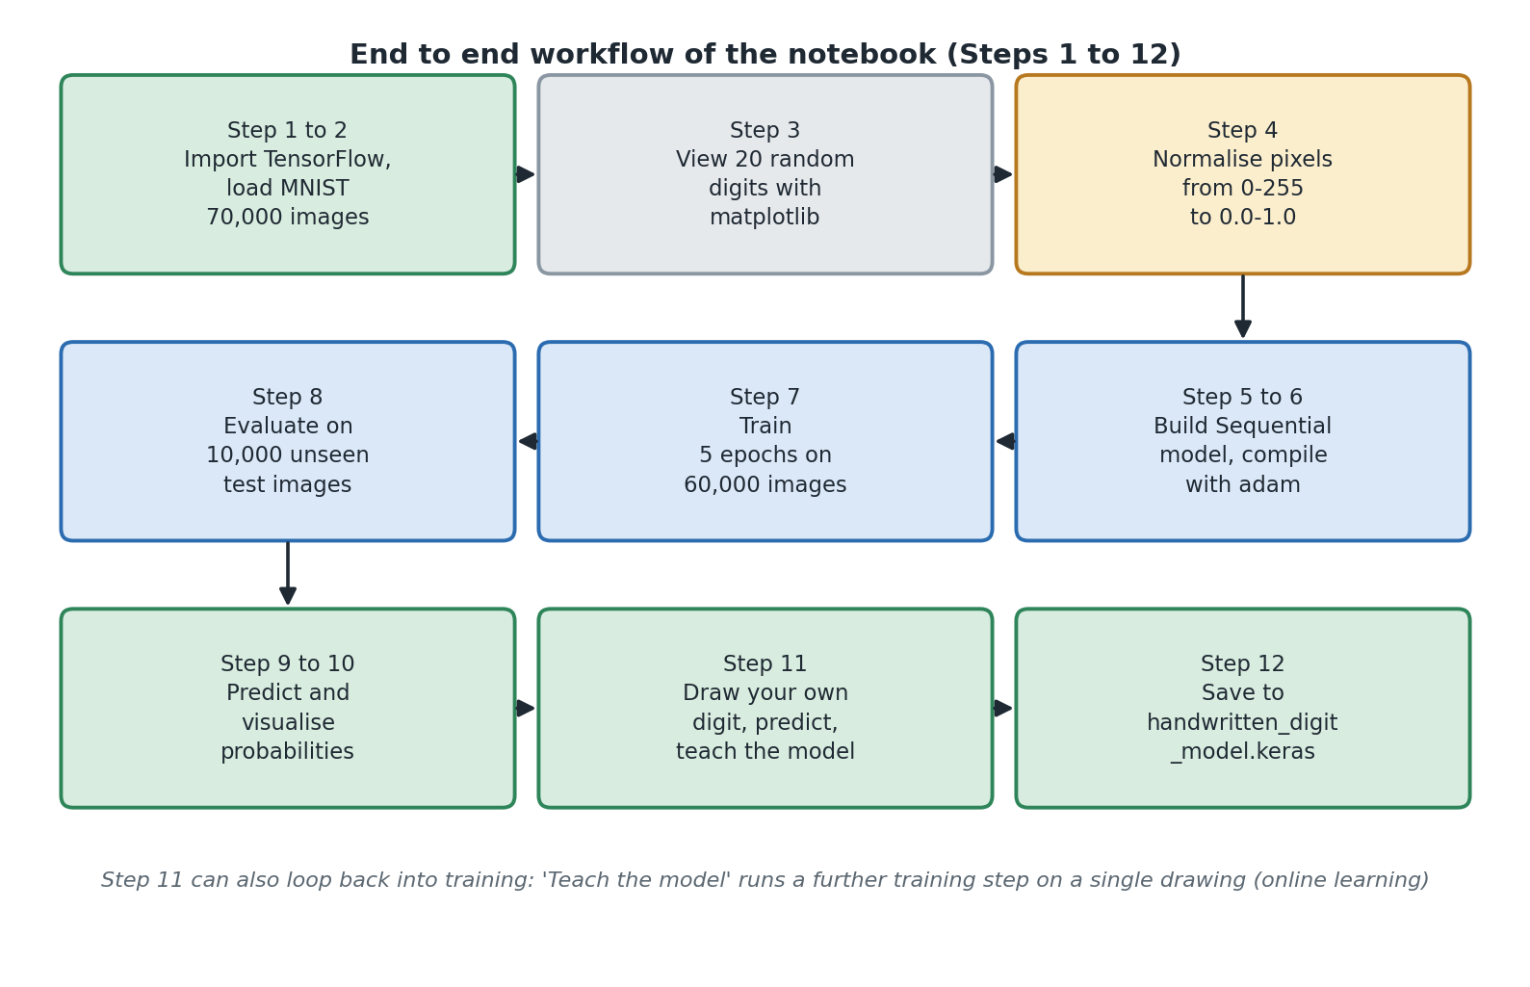
Diagram 1. The twelve steps of the project, from loading data to saving the model.
In short
The project trains a neural network to recognise single handwritten digits from 0 to 9.
It is one Jupyter notebook with twelve steps, written to teach you, not to be used in a real product.

3. Tools and setup
Key words in this section
Library: a collection of ready-made code that someone else has written for you to use.
Virtual environment (venv): a separate, private copy of Python for one project.
Kernel: the Python process that actually runs the code in your notebook.

3.1 The tools the project uses
The project needs six Python packages. Two more tools sit around them. Here is what each one does.
Tool | What it does here | What happens without it
TensorFlow | The main library. It builds the neural network, trains it, tests it and saves it. It also supplies the MNIST images. | Nothing works. This is the core of the project.
Keras | The friendly front end that comes inside TensorFlow. It is what you actually type when you build the network. | You cannot install it separately. It arrives with TensorFlow.
NumPy | Handles lists of numbers. Used to pick random images, and to find which digit the model chose. | Steps 3, 9, 10 and 11 fail.
Matplotlib | Draws all the pictures: the grid of sample digits, the bar charts, and your own drawing. | You can still train the model, but you cannot see anything.
ipycanvas | Provides the drawing canvas in Step 11. | Step 11 fails. Everything else is fine.
ipywidgets | Provides the buttons and the dropdown list in Step 11. | Step 11 fails.
Pillow | Crops and resizes your drawing so it matches the training images. | Step 11 fails. Note it is not in requirements.txt.
ipykernel | Tells Jupyter about your virtual environment so the notebook can use it. | The notebook may run against the wrong Python and cannot find TensorFlow.
Jupyter Lab or VS Code | The program you open the notebook in. | You cannot run the notebook.
Python 3.9 to 3.12 | The version of Python you need. TensorFlow does not work on 3.13 or newer. | The install of TensorFlow fails.
Pillow is not listed in requirements.txt because it gets installed automatically as part of Matplotlib. That works today, but it is worth knowing, because if a future version of Matplotlib stopped using Pillow, Step 11 would break with no obvious cause.

3.2 Installing and running the project
Type these commands one at a time in a terminal, in the project folder.
# 1. Create a private Python environment for this project
python -m venv .venv

# 2. Turn it on
.venv\Scripts\activate # Windows
source .venv/bin/activate # macOS or Linux

# 3. Install the six packages
pip install -r requirements.txt

# 4. Tell Jupyter about this environment
python -m ipykernel install --user --name=handwritten-digit-venv \
--display-name "Python (handwritten-digit-venv)"

# 5. Start Jupyter using the full path to this environment
.venv\Scripts\jupyter-lab.exe # Windows
.venv/bin/jupyter-lab # macOS or Linux
When Jupyter opens, open the notebook and check the kernel is set to Python (handwritten-digit-venv). In VS Code the kernel picker is at the top right. In Jupyter Lab it is under Kernel then Change Kernel.

3.3 Why a virtual environment is used
Different projects often need different versions of the same library. If everything is installed into one shared Python, one project can break another. A virtual environment solves this. The command in step 1 creates a folder called .venv containing a private copy of Python just for this project. Anything you install goes in there and affects nothing else on the machine.
This is standard practice in professional Python work, not something specific to machine learning. Getting used to it now will save you a lot of trouble later.

3.4 Why the last command uses a full path
Step 5 above starts Jupyter using the full path .venv/bin/jupyter-lab, rather than just typing jupyter lab. Both usually work. The full path is used because it removes any doubt about which Python is starting Jupyter.
Here is why that matters. Jupyter uses two separate Python processes.
Process | What it does | How it gets chosen
The kernel | Runs the code in your cells. | You choose it in the notebook, from the kernel menu.
The server | Runs the Jupyter interface itself, including the drawing widgets. | It is whichever Python was used to start Jupyter.
The drawing canvas in Step 11 is handled by the server, not by the kernel. So if the server was started from a different Python without ipycanvas installed, the canvas will not draw, even though you picked the right kernel. Using the full path guarantees the server comes from your virtual environment.
This is a good thing to understand because the symptom is confusing. The code does not crash. It runs, and instead of a canvas you see text like Canvas(height=280, ...). It looks like broken code but it is actually a setup problem.

3.5 If something goes wrong
What you see | Why | What to do
Text like Canvas(height=280, ...) instead of a canvas | Jupyter was started from the wrong Python, or an old Jupyter server is still running in the background. | Run jupyter server list, stop any servers for this folder, then start again using the full path.
The drawing area is squashed into a small scrolling box | Jupyter Lab shrinks tall outputs by default. | Right click the output and choose Disable Scrolling for Outputs.
pip cannot find a version of TensorFlow | You are on Python 3.13 or newer. | Check with python --version and use Python 3.9 to 3.12.
ModuleNotFoundError inside the notebook | The wrong kernel is selected. | Switch to Python (handwritten-digit-venv). If it is missing, run the ipykernel command again.
Accuracy is much lower than 97 percent | Step 4 was skipped, or cells were run out of order. | Restart the kernel and run every cell from the top, in order.
A NameError in Step 9 or later | You ran a cell before training finished. | Wait for Step 7 to print its finished message.
In short
Create a virtual environment, install the six packages, register it as a Jupyter kernel, then start Jupyter using the full path.
Most problems people hit are setup problems, not code problems.
Check you understood
1. Why does each project get its own virtual environment?
2. What is the difference between the Jupyter kernel and the Jupyter server?
3. Which two steps would fail if Pillow were missing?

4. The problem being solved
Key words in this section
Pixel: one dot in an image, stored as a number for how bright it is.
Classification: sorting something into one of a fixed set of categories.
Supervised learning: learning from examples that come with the correct answers.

4.1 What the computer actually receives
When you look at a handwritten 3, you see a curved stroke. You see it instantly, without thinking about it.
The computer does not see a stroke. It receives 784 numbers. Each number is how bright one pixel is. Nothing tells it which pixels are next to each other or that they form a shape. It has 784 numbers and it must decide which of ten digits they represent.
Keep this in mind for the rest of the guide. Everything the model eventually knows about shapes, it has to work out for itself from thousands of examples.

4.2 Why you cannot just write the rules
The obvious approach is to write rules. Try it for a 7. You might say: a horizontal line across the top, joined to a diagonal line going down and to the left.
Now think about the exceptions:
- A 7 with a line through the middle, which is normal in much of Europe.
- A 7 where the top line is very short, so it looks like a 1.
- A 7 with a curved diagonal rather than a straight one.
- A 7 written on a slant.
- A 7 drawn so thickly that the corner fills in.
- A 7 written in a hurry where the top line barely exists.
Every rule needs an exception, and every exception needs its own exception. Soon your rules for 7 start clashing with your rules for 1 and 9. The project contains 70,000 examples of how differently people write ten symbols. No sensible set of hand-written rules can cover that.

4.3 Turning the problem around
Machine learning swaps what you give the computer and what it gives back.
Approach | You give the computer | The computer gives you
Normal programming | Rules, and some data | Answers
Machine learning | Data, and the correct answers | Rules, in the form of learned numbers
This is called supervised learning. Supervised means every example comes with the right answer attached. MNIST does this: every image is labelled with the digit it shows.
The rules the computer produces are not sentences you can read. They are around a hundred thousand numbers. That is a real trade-off. The approach works where writing rules cannot, but you lose the ability to read the logic and explain any single decision. Section 17 comes back to this.

4.4 What kind of problem this is
Type of problem | The question it answers | Example | Is this it?
Binary classification | Is it A or B? | Is this email spam? | No
Multi-class classification | Which one of several categories is it? | Which of the ten digits is this? | Yes
Multi-label classification | Which of these categories apply, possibly several? | Which objects are in this photo? | No
Regression | What number is it? | What will this house sell for? | No
Object detection | What is in the picture and where? | Find every car in this street scene | No
This project is multi-class classification with ten categories that cannot overlap. An image is a 4 or it is a 9. It cannot be both.
That one fact decides several later design choices: the last layer has exactly ten outputs, and the settings in Steps 5 and 6 follow from it. Work out what type of problem you have first, then build the model to match.
In short
Writing rules by hand cannot cope with how much handwriting varies.
Instead you give the computer labelled examples and it works out the rules itself.
This project is multi-class classification with ten categories.
Check you understood
1. How many numbers does the computer receive for one image, and why that many?
2. What does supervised mean in supervised learning?
3. Give one thing you lose by using machine learning instead of hand-written rules.

5. Why TensorFlow is used
Key words in this section
Library or framework: ready-made code you build on top of.
Parameter: one of the numbers inside the model that gets adjusted during learning.
Tensor: a list of numbers, which may have several dimensions.

5.1 The job TensorFlow does
Getting a computer to learn rules from data sounds neat. Actually doing it needs a lot of code. You would have to:
1. Store the model as a big set of adjustable numbers.
2. Push thousands of images through it quickly.
3. Measure how wrong the answers were.
4. Work out how each individual number contributed to that wrongness.
5. Adjust every number a little, in the right direction.
6. Repeat thousands of times, then save the result.
Written from scratch that is thousands of lines of tricky maths code. TensorFlow exists so that none of it appears in your project. The whole model in this project is nine lines.

5.2 The six things TensorFlow gives this project
What it gives you | In plain terms | Where the project uses it
The dataset | Popular datasets are built in and download themselves. | One line loads all 70,000 MNIST images, already split into training and test sets.
Ready-made layers | Building blocks you snap together. | Flatten, Dense and Dropout in the main model. Conv2D and MaxPooling2D in the bonus.
Automatic maths | It works out how to improve each of the 101,770 numbers. | This is the hardest part of machine learning and none of it appears in the notebook.
Learning algorithms | Tested code for actually making the adjustments. | The optimizer is chosen just by writing the word "adam".
Speed | It does the number crunching in fast, optimised code. | Why training over 60,000 images finishes in under a minute on an ordinary laptop.
Saving | A standard file format for a trained model. | model.save writes one .keras file you can load again later.

5.3 TensorFlow and Keras
You will see both names. TensorFlow is the library. Keras is the simpler interface that comes inside it, and Keras is what you actually type.
This is why the notebook is readable. Look at the model code in section 8 and you can more or less tell what the network looks like just by reading it, even before you know what the words mean. That is deliberate.
The downside is that the maths is hidden. You can build a working model without understanding anything inside it. That is exactly the gap this guide is written to close.

5.4 What a tensor is
The name TensorFlow comes from the word tensor. A tensor is just a list of numbers, which can have any number of dimensions. It is worth knowing because error messages talk about shapes constantly.
Dimensions | Name | Example from this project
0 | A single number | The test accuracy, such as 0.9782
1 | A list | The ten probabilities for one image
2 | A grid | One 28 by 28 image
3 | A stack of grids | All 60,000 training images: shape (60000, 28, 28)
4 | A stack with an extra dimension | The same images with a colour channel added, used in the bonus section
Most beginner errors in TensorFlow are shape errors, where an array is the wrong size for the layer receiving it. Read the shape in the error message and compare it to this table.

5.5 What hardware it runs on
- On Windows, TensorFlow runs on the CPU only. GPU support was removed from Windows versions in TensorFlow 2.11. The README says so.
- That is fine here. This project is small and trains in well under a minute.
- For GPU speed on Windows, the README suggests WSL2 or a package called tensorflow-directml-plugin.
- A saved model file is only numbers. To use it you still need TensorFlow installed.

5.6 Where a trained model can end up
This is not in the project, but it is the obvious question once you have a saved model, and it is one reason companies choose TensorFlow.
Where | How | Used for
A Python program | Load the .keras file and call predict. | Office systems, batch processing of scanned documents.
A phone or small device | Convert it to TensorFlow Lite. | Scanning something in a phone app, handheld meter readers.
A web browser | Convert it to TensorFlow.js. | A demo where the image never leaves the user's computer.
A busy server | Export it and host it with TensorFlow Serving. | Handling many requests per second behind an API.
In short
TensorFlow does the hard maths so you only have to describe the network.
Keras is the simple interface inside TensorFlow that you actually type.
A tensor is just a list of numbers with one or more dimensions.

6. The data: MNIST
Key words in this section
Dataset: a collection of examples used to train or test a model.
Label: the correct answer attached to an example.
Training set and test set: examples used for learning, and examples held back for checking.

6.1 What is in it
MNIST contains 70,000 pictures of handwritten digits. Each picture is 28 pixels wide and 28 pixels tall, in shades of grey. Each one comes with a label saying which digit it shows.
mnist = tf.keras.datasets.mnist
(x_train, y_train), (x_test, y_test) = mnist.load_data()
That one line gives you four things.
Name | Shape | What it holds
x_train | (60000, 28, 28) | 60,000 pictures for training
y_train | (60000,) | The correct digit for each of those pictures
x_test | (10000, 28, 28) | 10,000 pictures kept back for testing
y_test | (10000,) | The correct digit for each test picture
The notebook prints all four shapes straight after loading. Get into that habit. Checking the shape of your data before you use it catches a lot of confusion later on.

6.2 Why the data is split in two
This is one of the most important ideas in the whole guide, so it is worth being clear about.
If you test a model on pictures it already learned from, it might just be remembering them. That tells you nothing useful. What you actually want to know is whether it can handle handwriting it has never seen.
So 10,000 pictures are put aside at the start and never shown during training. They are only used at the end, to score the model. That score is the honest one.
The rule to follow: decide the split at the beginning and never cross it. Using the test data to help you make choices is a quiet way to end up with results that look great and then fail in the real world.

6.3 Looking at the data first
Step 3 shows 20 random training images in a grid, each with its correct label. It picks different ones every time you run it.
random_indices = np.random.choice(len(x_train), size=20, replace=False)
plt.figure(figsize=(10, 8))
for plot_position, index in enumerate(random_indices):
plt.subplot(4, 5, plot_position + 1)
plt.imshow(x_train[index], cmap="gray")
plt.title(f"Label: {y_train[index]}")
plt.axis("off")
This step does not train anything or improve any score, and it is still one of the most valuable steps in the notebook. Looking at real examples shows you how much the handwriting varies, how thick the strokes are, and how some digits are genuinely hard to read even for you. It also catches obvious problems, such as labels not matching the pictures.

6.4 Three things about MNIST that matter later
These three details explain several decisions further on. Note them now.
- The digits are white on a black background. That is why the drawing canvas in Step 11 is black with a white pen, and not the other way round.
- The digits are all a similar size and sit in the middle of the picture with a gap around the edge. That is why the canvas code crops and re-centres your drawing before showing it to the model.
- The strokes are fairly thick. That is why the canvas uses a thick pen, and why the README tells you to draw big and bold.
The rule behind all three: whatever the training pictures look like, anything you show the model later has to look the same. Section 13 turns this into the single most useful lesson in the project.

6.5 What MNIST is not
MNIST is great for learning and a poor match for the real world. Learners often see 98 percent and assume the problem is solved, so it is worth being honest about its limits.
- Every picture holds exactly one digit, already cut out for you. Real documents do not.
- Every digit is neatly sized and centred. Real handwriting is not.
- The handwriting comes from one group of people, collected decades ago. Digits are written differently in different countries.
- The pictures are clean. No smudges, no lined paper, no shadows, no coloured ink.
- Every input is guaranteed to be one of the ten digits. The model has no way to say this is not a digit at all.
In short
MNIST is 70,000 labelled pictures of handwritten digits, 28 by 28 pixels each.
60,000 are used for training and 10,000 are held back to test honestly.
MNIST digits are white on black, centred, similar in size and thick. Anything you show the model later must match.
Check you understood
1. Why must the test images never be used during training?
2. What does the shape (60000, 28, 28) mean?
3. Name two ways MNIST is easier than real handwriting.

7. Preparing the data
Key words in this section
Normalisation: scaling numbers into a small, consistent range.
Flattening: turning a grid of numbers into a single long list.

7.1 What a pixel is here
Each pixel is one whole number from 0 to 255. 0 means black, 255 means white, and everything in between is a shade of grey. There is no colour, so one number per pixel is enough.
A 28 by 28 picture is therefore 784 numbers, and that is the entire picture as far as the computer is concerned.

7.2 Normalisation
x_train = x_train / 255.0
x_test = x_test / 255.0
Two lines divide every pixel by 255. That turns the range 0 to 255 into the range 0.0 to 1.0. This is called normalisation.

Why it helps
A neuron multiplies each input by a number and adds them all up. With 784 inputs each up to 255, those totals get very large before any learning has happened. Large, uneven numbers make the learning process unstable: some adjustments end up far too big and others far too small.
Scaling everything into the same small range makes the maths behave. Training gets faster and, more importantly, more reliable.
This is not a small tweak. If you skip it, the model usually still learns, but more slowly and to a lower final score. Try it, because seeing that happen makes the point better than reading about it does.

Do it the same way every time
Whatever you do to the training data, you must do to anything else the model sees. The project does this in two places: x_test is divided on the same line as x_train, and your own drawing in Step 11 is divided by 255 before being handed to the model. Miss either one and the model appears to work but produces nonsense.

7.3 Flattening, and what it costs
The Flatten layer takes the 28 by 28 grid and lays it out as a single list of 784 numbers. This is needed because the kind of layer used next expects a flat list, not a grid. Flatten does not learn anything. It only rearranges.
But there is a cost. Once flattened, the information about which pixels were next to each other is gone. Two pixels that sat one above the other are now 28 places apart in a list, and nothing tells the network that this means anything.
Here is a striking way to put it. If you shuffled the 784 positions into a random order, and used the exact same shuffle for every single image, the network would learn just as well. It has no idea the picture is a picture.
This limitation is exactly what the bonus section fixes, and it is why section 16 treats convolutional networks as the natural next step rather than an optional extra.

7.4 The shape at each stage
Stage | Shape of one image | Range of values
Loaded from MNIST | 28 by 28 | 0 to 255, whole numbers
After normalisation | 28 by 28 | 0.0 to 1.0
After Flatten | 784 | 0.0 to 1.0
After the hidden layer | 128 | 0.0 or more
After the output layer | 10 | 0.0 to 1.0, adding up to 1.0
For the bonus CNN | 28 by 28 by 1 | 0.0 to 1.0, with a channel added
In short
Divide every pixel by 255 so the numbers sit between 0 and 1. This makes training work properly.
Flatten turns the 28 by 28 grid into a list of 784 numbers, and loses all information about which pixels were next to each other.

8. How the neural network works
Key words in this section
Layer: one stage of the network that takes numbers in and passes numbers out.
Neuron: one small calculator inside a layer.
Weight: a learned number saying how much one input matters.
Bias: one extra learned number added on at the end.
Activation function: a simple function applied to a neuron's result.
Softmax: the function that turns the final scores into percentages.
This is the most important section in the guide. Take it slowly. Everything here refers to the actual model the project builds in Step 5.
model = tf.keras.models.Sequential([
tf.keras.layers.Input(shape=(28, 28)),
tf.keras.layers.Flatten(),
tf.keras.layers.Dense(128, activation="relu"),
tf.keras.layers.Dropout(0.2),
tf.keras.layers.Dense(10, activation="softmax")
])
Sequential means the layers are stacked in a straight line. Each one passes its output to the next. There are no branches or loops. It is the simplest useful arrangement and the right one to start with.
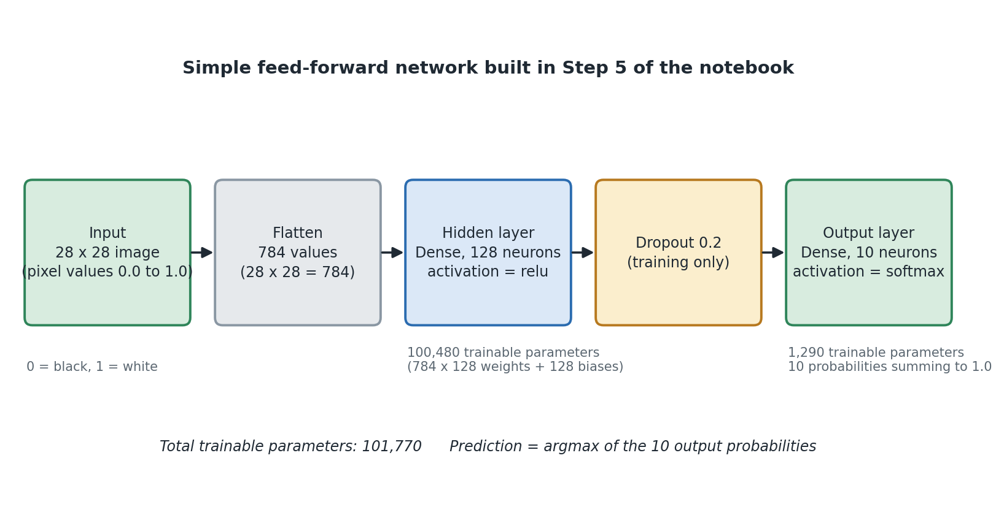
Diagram 2. The five layers of the network, left to right.

8.1 The word neural
These are called neural networks because of a loose comparison with the brain. A brain cell receives signals from many others and fires when the total is big enough. An artificial neuron receives many numbers, combines them, and produces an output depending on whether the total is big enough.
That is where the comparison ends. Artificial neurons sit in neat fixed rows, all do the same simple sum, and are trained by a method that has nothing to do with biology. Treat the name as history, not description.

8.2 What one neuron does
Every neuron in a Dense layer holds one weight for each input, plus one bias. It does this:
1. Multiply each input by that input's weight.
2. Add all those results together.
3. Add the bias.
4. Put the total through the activation function.
total = (w1 * x1) + (w2 * x2) + ... + (w784 * x784) + bias
output = relu(total)
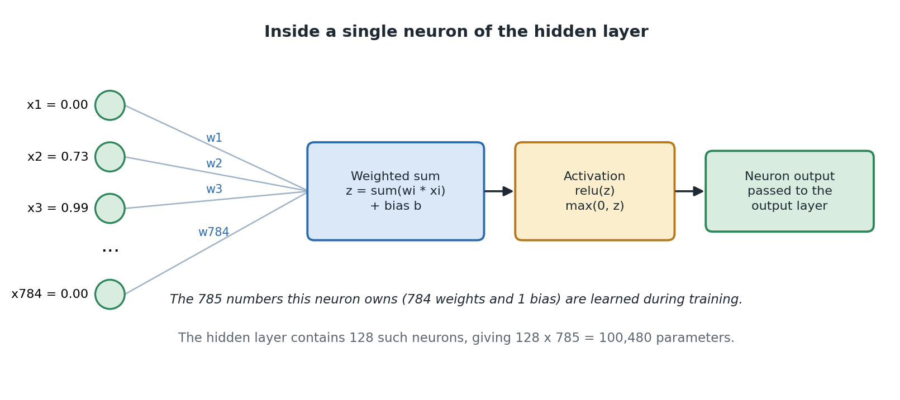
Diagram 3. One neuron: a weighted sum, then an activation function.

Weights
A weight says how much one particular pixel matters to one particular neuron.
- A big positive weight means: when this pixel is bright, push my output up.
- A big negative weight means: when this pixel is bright, push my output down.
- A weight near zero means: I do not care about this pixel.
The weights are what the network learns. Nobody sets them by hand. Training changes them until the answers come out right. So a trained neuron is a detector for some pattern of light and dark pixels, and nobody chose which pattern. The training process settled on whatever turned out to be useful.

Bias
The bias is one extra number added at the end, the same every time regardless of the input. It shifts how easily the neuron switches on. It is one extra number per neuron and it matters more than its size suggests: without it, a neuron receiving all zeros would always output zero, which removes useful flexibility for no reason.

8.3 Activation functions, and why they are needed
This part is often skipped and it is worth understanding, because it explains why a network with several layers is worth building at all.
Suppose there were no activation functions and every layer just did the weighted sum. Adding up weighted sums gives you another weighted sum. So a hundred stacked layers would do exactly the same job as one layer. The network could only ever learn very simple straight-line relationships, which is nowhere near enough to tell a 3 from an 8.
An activation function is a small bend put in between the layers. That bend is what stops everything collapsing into one layer, and it is why extra layers actually buy you something.
Function | What it does | Where it is used | Here?
relu | If the number is positive, keep it. If it is negative, make it 0. | The normal choice for hidden layers. | Yes, in the hidden layer
softmax | Turns a set of scores into percentages that add up to 100. | The last layer when the answer is one of several options. | Yes, in the output layer
sigmoid | Squashes any number into the range 0 to 1, on its own. | Yes or no answers, or when several answers can be true at once. | No
tanh | Squashes any number into the range minus 1 to 1. | Common in older networks before relu took over. | No
none | Leaves the number alone. | When the answer is an unbounded number, like a price. | No

Why relu
relu is almost embarrassingly simple: negative becomes zero, positive stays as it is. It became the standard choice for three reasons. It is extremely fast to calculate, being one comparison. It does not flatten out for large values, so learning keeps making progress instead of stalling. And because about half of the neurons output exactly zero at any moment, the network tends to generalise better.

8.4 The input layer
The Input layer just declares what shape of data to expect, which here is 28 by 28. It has no neurons and learns nothing. Flatten then turns that grid into 784 numbers. Together these two form what people call the input layer: 784 numbers, each between 0.0 and 1.0.
The size of the input layer is decided by the data, not by you. 28 times 28 is 784, always. If the pictures were 64 by 64, there would be 4,096 inputs instead.

8.5 The hidden layer
The hidden layer is a Dense layer with 128 neurons and relu activation. Dense means fully connected: every one of the 128 neurons sees all 784 inputs.
It is called hidden because it is neither the data you put in nor the answer you read out. It is the network's own private working-out. You never look at these numbers in normal use, and there is no reason any single one of them should mean anything a human would name.

What it is for
Think of the hidden layer as squeezing 784 raw pixels down into 128 useful summaries. Each summary is some combination of pixels that turned out to help tell digits apart. The output layer then works from those 128 summaries instead of from raw pixels.
This is the whole idea behind having layers at all. Rather than asking one layer to jump straight from pixels to answers, you split the job: one layer finds useful descriptions, the next uses them to decide. Add more layers and the descriptions get more abstract. That is what the word deep means in deep learning.

Why 128 neurons
Nobody calculated 128. It is a choice, and it acts like a dial for how much the network can learn.
Setting | What happens | How you spot it
Too small, say 8 | Not enough room to learn the variety in the data. | Both training and test scores stop improving at a low level.
About right, say 128 | Enough room to learn general patterns without too much freedom. | Training and test scores are both high and close to each other.
Too big, say 4096 | More room than the job needs. Slower, and more likely to memorise. | Training score almost perfect, test score clearly lower.
128 is a comfortable, conventional choice for this dataset. The README invites you to change it and see what happens, which is the right way to get a feel for it. There is no formula, so you build intuition by turning the dial and watching.

8.6 Dropout
Dropout(0.2) sits between the hidden layer and the output layer. While training, it randomly switches off 20 percent of the hidden neurons on each pass. A different random 20 percent each time.
Why deliberately break your own network? Because it stops any one neuron becoming essential. If the answer depends on one neuron, the network has found a fragile shortcut rather than a general pattern. Since any neuron might disappear at any moment, the network is forced to spread what it knows across many of them.
Two things people get wrong about dropout:
- It only happens during training. It is switched off automatically when the model is being tested or making predictions, so it never makes your answers random.
- It learns nothing. It has no weights and no biases, which is why model.summary() shows it with zero parameters. It is a behaviour, not a store of numbers.
0.2 is a gentle setting. The bonus CNN uses 0.3. Above about 0.5 it usually starts to do more harm than good, because too much of the network is missing on each pass.

8.7 The output layer
The output layer is a Dense layer with exactly 10 neurons, one for each digit. Unlike the hidden layer size, this is not a choice. Ten possible answers means ten outputs.
Each of the ten neurons produces a raw score, which can be any number at all, positive or negative. Softmax then turns those ten scores into ten percentages that add up to exactly 1.

What softmax does
Softmax raises each score to a power to make it positive and exaggerate the differences, then divides each one by the total so they all add up to 1. Here is a small example with three scores instead of ten.
# example only, not project code
raw scores [1.0, 4.0, 0.5 ]
after exponent [2.72, 54.60, 1.65]
total 58.97
after dividing [0.046, 0.926, 0.028] adds up to 1.0
Because they add up to 1, you can read them as confidence. It also builds in the rule that only one answer can be right: if one digit's number goes up, the others must go down.
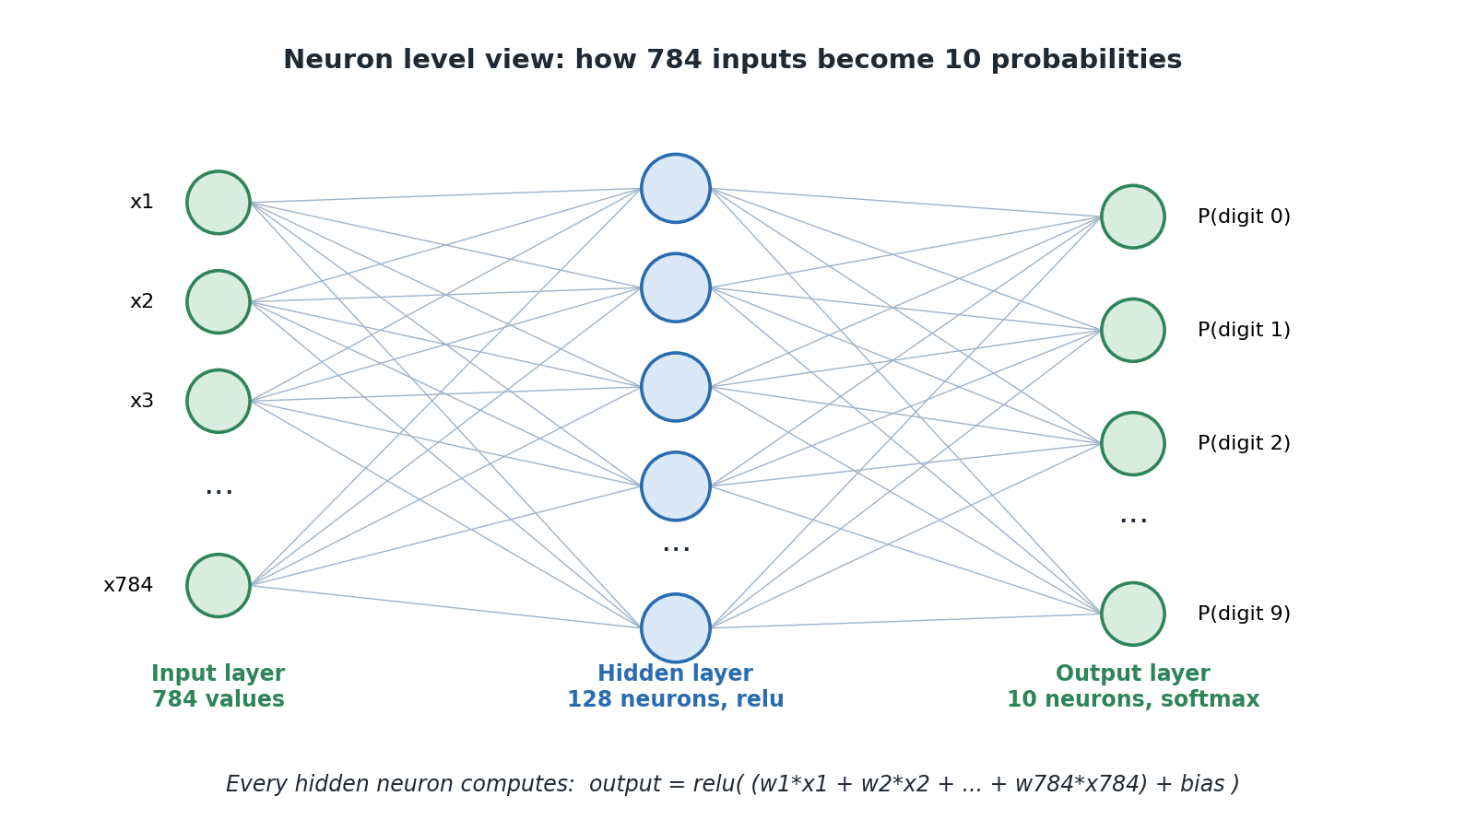
Diagram 4. The three layers, showing that every neuron connects to every neuron in the next layer.

8.8 Counting the learned numbers
The notebook calls model.summary() to print how many numbers the model has to learn. Working it out yourself makes it much clearer what learning actually means.
Layer | Numbers it learns | How that is worked out
Input | 0 | It only declares a shape.
Flatten | 0 | It only rearranges.
Dense, 128 neurons | 100,480 | 784 inputs x 128 neurons = 100,352 weights, plus 128 biases.
Dropout | 0 | It is a behaviour, not stored numbers.
Dense, 10 neurons | 1,290 | 128 inputs x 10 neurons = 1,280 weights, plus 10 biases.
Total | 101,770
Those 101,770 numbers are the model. Training means finding good values for them. The file you save in Step 12 is basically a container holding them.
Notice that almost 99 percent of them are in the first Dense layer, simply because 784 times 128 is a lot of connections. This is normal for this kind of network, and it is one reason the convolutional network in section 16 is more efficient.

8.9 Following one image all the way through
1. An image arrives as a 28 by 28 grid of numbers between 0.0 and 1.0.
2. Flatten turns it into a list of 784 numbers. Nothing is calculated.
3. Each of the 128 hidden neurons multiplies all 784 numbers by its own weights, adds them up, adds its bias, and applies relu. The layer produces 128 numbers.
4. Dropout does nothing here, because this is a prediction and not training.
5. Each of the 10 output neurons multiplies those 128 numbers by its own weights, adds them up and adds its bias. The layer produces 10 raw scores.
6. Softmax turns those 10 scores into 10 percentages adding up to 1.
7. np.argmax finds the position of the biggest one. That position is the answer.
Altogether that is 101,632 multiplications for one image. TensorFlow does them as two big block calculations, which is why thousands of images can be predicted in a fraction of a second.

8.10 Designing your own network
Right. You now know what every layer in this project does and why it is there. The natural next question is: could you build one yourself, for a different problem, without copying somebody else's code? Yes, you could, and this section is about how.
The trick is realising that most of the design is not actually up to you. Some parts are forced by the problem, some are conventions you follow until you have a reason not to, and only a small handful are genuinely open choices. Once you separate those three groups, designing a network stops feeling like guesswork.

Step 1: work out what is forced
Three parts of the design are decided for you before you touch the keyboard. Get these wrong and nothing else matters.
What | Decided by | In this project
The size of the input layer | The shape of your data. Count the numbers in one example. | 28 x 28 = 784 values
The number of output neurons | How many possible answers there are. | 10, one per digit
The output activation and the loss | What kind of question you are asking. | softmax and sparse categorical crossentropy, because it is one answer out of ten
That third row is the one people get wrong, so here is the full lookup. Find your row, use those two settings, and stop thinking about it.
Your question | Output layer | Loss function
One answer out of several (this project) | One neuron per category, softmax | sparse_categorical_crossentropy for whole-number labels, categorical_crossentropy for list labels
Yes or no | 1 neuron, sigmoid | binary_crossentropy
Several answers can be true at once | One neuron per category, sigmoid | binary_crossentropy
A number with no fixed range, like a price | 1 neuron, no activation | mean_squared_error

Step 2: follow the conventions
These are not laws, but they are what everybody does, and you should have a specific reason before deviating. Sticking to them means the interesting problems you hit are real ones rather than self-inflicted.
- Use relu on every hidden layer. It is the default for good reason. Only reach for something else once you know why.
- Use adam as your optimizer, and leave its settings alone. Tune the network before you tune the optimizer.
- Normalise your input into a small range, roughly 0 to 1 or centred on 0. Always. There is no situation in this kind of work where feeding in raw 0 to 255 values is the right call.
- Put dropout between your big layers, not after the output. Somewhere between 0.2 and 0.5.
- Make the layers get narrower as you go, not wider. 784 into 128 into 10 is a funnel, and that shape is normal because each layer is meant to be summarising what came before it.

Step 3: make the choices that are actually yours
What is left is a short list: how many hidden layers, how wide each one is, how much dropout, and how many epochs. That is basically it. Here is how to think about each.

How many hidden layers
Start with one. Seriously, start with one. A single hidden layer can learn a surprising amount, and this project proves it by hitting 98 percent with exactly one. Add a second only when you have trained the first and found it plateauing below what you need.
Each extra layer lets the network build more abstract descriptions on top of the previous ones. That is genuinely powerful for complex data. It also makes training slower, makes overfitting easier, and gives you more places for something to go wrong. Depth is a tool, not a score.

How wide each layer should be
The honest answer is that people pick a power of two between 32 and 512 and adjust from there. 32, 64, 128, 256, 512. There is no deep reason for powers of two, it is habit and a mild hardware efficiency thing, but it is what you will see everywhere.
A sensible starting point is somewhere between the size of your input and the size of your output, closer to the output end. This project goes 784 into 128 into 10, which fits. If your input were 50 values and you had 3 categories, something like 32 would be a reasonable first guess.
Then you tune it by watching what happens, which is the whole point of section 8.5's table. Too narrow and both scores stay low. Too wide and the training score races ahead of the test score.

How much dropout
If your training and test scores are close together, you may not need any. If they are drifting apart, add some or increase what you have. Start at 0.2, and if you are still overfitting go to 0.3 or 0.4. Above 0.5 you are usually doing more harm than good, because so much of the network is missing on each pass that it struggles to learn anything at all.

Step 4: build the smallest thing that could work, then grow it
This is the bit that separates people who make progress from people who get stuck. Do not design your final network up front. Build something deliberately simple, get it training end to end, and only then make it bigger.
1. Build the simplest network that fits your problem. One hidden layer, no dropout.
2. Train it for just a few epochs. You are not trying to get a good score yet. You are checking that the whole pipeline runs, the shapes match and the loss goes down at all.
3. Now train it properly and write down both the training and test scores.
4. Look at the gap. Both low means underfitting, so make the network bigger or train longer. Big gap means overfitting, so add dropout, get more data, or make it smaller.
5. Change one thing. Retrain. Compare. Repeat.
That last instruction matters more than it looks. Change one thing at a time. If you change the layer size, the dropout rate and the epoch count together and the score improves, you have learned nothing about which change helped.

A worked example: designing for a different problem
Say you want to classify small photos of six types of fruit. The images are 64 by 64 in colour. You have 5,000 labelled examples. Work through it in order.
Decision | Reasoning | Result
Input size | 64 x 64 x 3 colour channels = 12,288 values per image. | Input shape (64, 64, 3)
Output neurons | Six fruits, and a photo is only one fruit. | 6 neurons, softmax
Loss | One answer out of several, labels stored as whole numbers 0 to 5. | sparse_categorical_crossentropy
Layer type | Images, and lots of input values. Flattening 12,288 pixels into a dense layer would need millions of parameters. | Use convolutional layers, as in section 16
Hidden size | Start modest. Somewhere between input and output, nearer the output. | One dense layer of 64 after the conv layers
Dropout | Only 5,000 examples for 6 categories, so overfitting is likely. | Start at 0.3
Epochs | Unknown. Start at 10 and watch the two scores. | See section 10.3
Notice how little of that was invention. Four of the seven rows were forced or conventional. Only the hidden size, the dropout and the epoch count were real judgement calls, and even those came with a sensible starting point.

Mistakes that catch everyone at least once
The mistake | What you will see | The fix
Forgetting to normalise | Trains badly or barely at all. | Divide your input by its maximum, or scale it to 0 to 1.
Wrong loss for the label format | A shape error the moment training starts. | Whole-number labels use the sparse version. List labels use the other one.
Wrong number of output neurons | Either a shape error, or it silently cannot predict some categories. | Count your categories again.
softmax on a hidden layer | It trains, badly, and you may not notice. | relu on hidden layers, softmax only on the output.
Testing on the training data | A brilliant score and a terrible product. | Keep a test set aside and never train on it.
Making it huge immediately | Slow training, heavy overfitting, no idea which part is wrong. | Start small. Grow it one change at a time.
In short
Input size, output size, output activation and loss are all forced by the problem. Work those out first.
relu, adam, normalised input and a funnel shape are conventions. Follow them until you have a reason not to.
Only the number and width of hidden layers, the dropout and the epochs are really your call.
Start with the smallest thing that could work, then change one thing at a time.
Check you understood
1. You are classifying emails as spam or not spam. How many output neurons, which activation, and which loss?
2. Which is a hyperparameter and which is a parameter: the number of epochs, or a weight in the hidden layer?
3. Your training score is 96 percent and your test score is 94 percent. Should you add dropout or make the network bigger?
In short
A neuron multiplies each input by a weight, adds them up, adds a bias, and applies an activation function.
The hidden layer turns 784 pixels into 128 useful summaries. The output layer turns those into 10 percentages.
Learning means adjusting 101,770 weights and biases until the answers come out right.
Check you understood
1. What is the difference between a weight and a bias?
2. What would go wrong if you removed all the activation functions?
3. Why does the output layer have exactly 10 neurons, and why is that not a choice?
4. Why does Dropout show 0 parameters in the model summary?

9. Setting up the learning
Key words in this section
Optimizer: the method used to adjust the weights.
Loss: a single number saying how wrong a prediction was.
Metric: a score reported for humans to read, such as accuracy.
model.compile(
optimizer="adam",
loss="sparse_categorical_crossentropy",
metrics=["accuracy"]
)
Compiling does not train anything and does not change a single weight. It just sets up how training will work later. Nothing visible happens when you run this cell, which catches people out.
Setting | Value here | What it is for
Optimizer | adam | Decides how to adjust the weights after each look at the data.
Loss | sparse_categorical_crossentropy | Gives a single number for how wrong the answers were. Training tries to make this smaller.
Metric | accuracy | The percentage right. Reported for you to read, but not what training aims at.

9.1 The optimizer
Training is a search. There are 101,770 numbers and you need a combination of values that gives good answers. The optimizer is the search method.
The basic method is called gradient descent. A useful picture is walking downhill in fog. You cannot see the bottom of the valley. But you can feel which way the ground slopes under your feet, so you take a step downhill, then feel again, then step again. Do that enough times and you get low.
In training, the ground is the loss and the slope tells you, for every weight, whether nudging it up or down would reduce the loss. The optimizer takes a small step in that direction for every weight, then repeats.
How big a step you take is called the learning rate. Too big and you stride back and forth across the valley without ever settling. Too small and you take all day.

What adam adds
Adam is a smarter version of the same idea. It keeps a separate step size for each individual weight, adjusted from how that weight has been behaving recently. It also has momentum, meaning it builds up a sense of direction rather than reacting only to the last measurement.
The practical reason the notebook uses it: adam works well straight out of the box on almost anything, without you having to tune the step size. The notebook describes it as taking bigger steps when it is far from a good answer and smaller, more careful steps as it gets close, which is a fair summary.

9.2 The loss
The loss is one number saying how wrong a prediction was. Lower is better, and it is the only thing training actually tries to improve.
You might reasonably ask why accuracy is not used instead. The reason is that accuracy only changes when a prediction flips from wrong to right. Going from 30 percent confident in the right answer to 49 percent confident changes nothing in the accuracy, so there is no signal telling the model it improved. Loss changes smoothly all the time, which is what the downhill search needs.

How this loss behaves
Crossentropy looks at how much confidence the model put on the correct answer, and punishes it more the lower that confidence was. The punishment rises very steeply as the confidence approaches zero.
Confidence in the correct digit | Roughly this much loss | What it means
0.99 | 0.01 | Confident and right. Almost no penalty.
0.90 | 0.11 | Right, with a bit of room to improve.
0.50 | 0.69 | Right, but only just. A real penalty.
0.10 | 2.30 | Probably wrong. Heavy penalty.
0.01 | 4.61 | Confidently wrong. Very heavy penalty.
That steep rise is deliberate. It teaches the model not to be confidently wrong, which is what makes its confidence figures worth anything at all.

Why the word sparse
There are two versions of this loss. The sparse one is for when your labels are plain numbers, like 7. The other is for when your labels are lists like [0,0,0,0,0,0,0,1,0,0]. MNIST labels are plain numbers, so sparse is correct here.
Picking the wrong one is one of the most common beginner mistakes. It gives an error about shapes as soon as training starts, so at least it fails loudly.
In short
Compiling sets up how learning will work. It does not train anything.
The optimizer walks the weights downhill. The loss is the slope it follows. Accuracy is just for you to read.

10. Training the model
Key words in this section
Batch: a small group of images processed together.
Epoch: one complete pass through all the training images.
Backpropagation: working out how much each weight contributed to the error.
print("Training the model - please wait for this to finish...")
history = model.fit(x_train, y_train, epochs=5)
print("Training complete!")
One line does the entire learning process. The notebook prints messages either side, because running the next cell before training finishes is a very common mistake and produces errors that look like they are about something else.

10.1 What happens inside
This cycle repeats thousands of times.
1. Forward pass. Take 32 images, run them through the layers, get 32 predictions.
2. Loss. Compare those predictions with the correct answers and get one number for how wrong they were.
3. Backward pass. Work backwards through the network to find how much each of the 101,770 weights contributed to that error. This is called backpropagation, and section 15 opens it up so you can watch it happen.
4. Update. The optimizer nudges every weight in the direction that reduces the error. Then start again with the next 32 images.
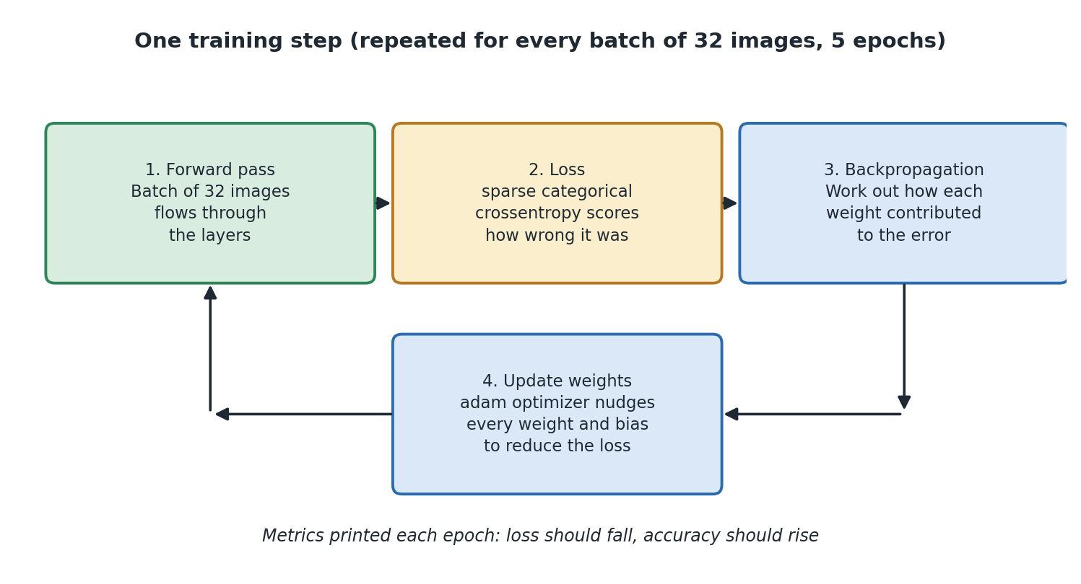
Diagram 5. The four stages of one training step, repeated thousands of times.

10.2 Batches and epochs
Three words get confused constantly. Here they are with this project's numbers.
Word | What it means | Value here
Batch | How many images are handled together before the weights are changed once. | 32, which is the default
Iteration or step | One batch going all the way round the loop above. | 60,000 divided by 32 = 1,875 per epoch
Epoch | One full pass through all the training images. | 5
Total updates | Iterations per epoch times number of epochs. | 1,875 x 5 = 9,375

Why not just do one image at a time?
Two extremes show why batching makes sense. Update after every single image and the adjustments are wildly erratic, because one image is not representative of anything. Update only after all 60,000 and you get one very careful adjustment per epoch, which is far too few to get anywhere. Batches of 32 sit in between: each adjustment is based on a reasonable sample, and 32 images can be processed almost as fast as one because of how the maths is done underneath.
There is a bonus to the wobbliness, by the way. Because each batch is a slightly different sample, the adjustments jiggle about a bit rather than heading in a dead straight line. That jiggle actually helps, because it stops the search settling into the first mediocre spot it finds. This is one of those cases where a bit of noise is a feature rather than a bug.

10.3 Epochs in detail, and the point where more becomes worse
Epochs deserve a section of their own, because this is the setting people reach for first when they want a better score, and it is the one that will quietly betray you.

What one epoch actually is
An epoch is one complete pass through every training image. In this project that is all 60,000 pictures, in batches of 32, which works out at 1,875 weight adjustments. Then epoch two starts and does the whole lot again. And again, five times in total.
A fair question at this point: why show it the same pictures more than once? It has already seen them. Surely it either learned from a picture or it did not?
The answer is that each adjustment is deliberately small. The optimizer never jumps straight to the right answer for a picture, it just nudges the weights slightly in a helpful direction. And because all 101,770 numbers are shared across all ten digits, an adjustment made to get one 7 right may partly undo something that was helping with 1s. So the network needs to see everything repeatedly, gradually settling into a set of numbers that works reasonably for all of it at once. Think less like memorising a fact and more like slowly tuning a radio.

What happens across the epochs
Roughly when | What the network is doing | What you see
Epoch 1 | Learning the crude, obvious stuff. Where ink usually is. Which broad shapes go with which digits. | The biggest single jump in accuracy of the whole run. Often 90 percent or better straight away.
Epochs 2 to 4 | Refining. Learning the harder distinctions, like 4 versus 9, and coping with unusual handwriting. | Steady but much smaller gains. A percent or so per epoch.
Around epoch 5 here | Most of the general pattern has been learned. | Gains become small and irregular. This is why the project stops at 5.
Beyond that | Running out of general patterns to learn, so it starts fitting the quirks of individual training images. | Training score keeps creeping up. Test score stops improving.
Well beyond that | Actively memorising the training set. | Training score approaches perfect. Test score gets worse.

The critical point
Here is the thing that catches people out. Training accuracy almost never gets worse with more epochs. It goes up, and up, and eventually flattens near perfect. So if that is the number you are watching, more epochs always looks like an improvement.
Test accuracy does something different. It climbs, reaches a peak, and then declines. That peak is the critical point, and it is the number of epochs you actually wanted.
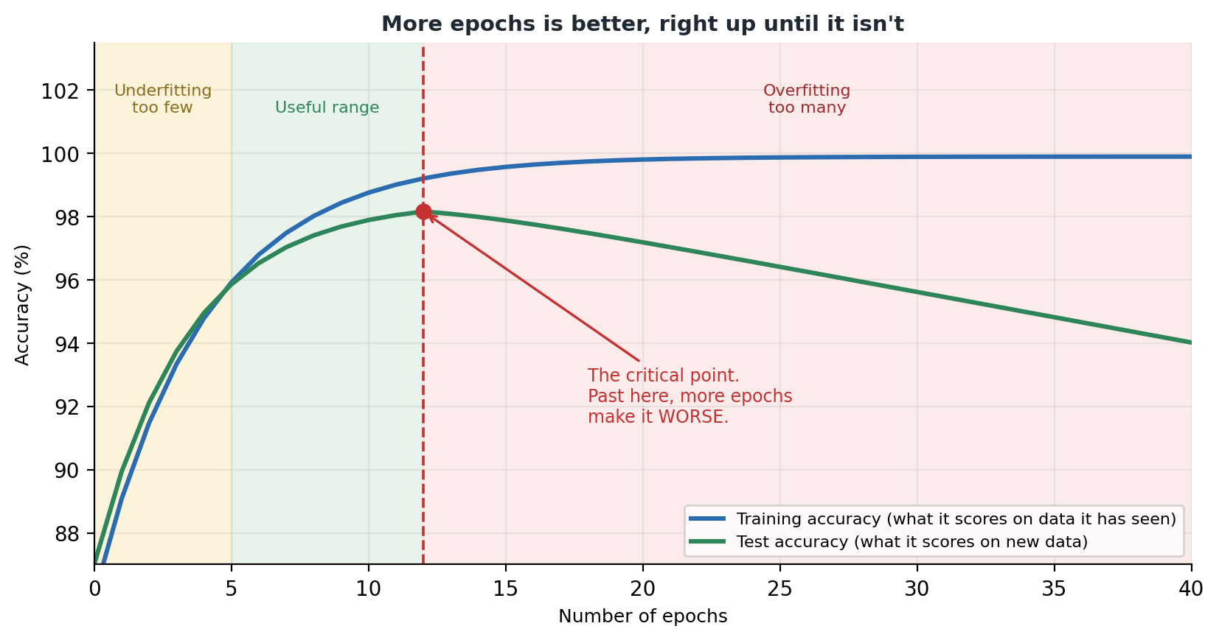
Diagram 6. Training accuracy keeps rising. Test accuracy peaks and then falls. The gap between the two lines is overfitting.

Why more training makes it worse
It sounds backwards. More practice should mean better performance. So what is going on?
Remember the exam revision comparison from section 1.4. In the early epochs the model is learning genuine patterns, the things that make a 7 a 7 in general. Those patterns help on any 7, including ones it has never seen. That is why both scores rise together at the start.
But eventually it has extracted all the general patterns that are there to extract. The loss can still be reduced, though, because the training images each have their own little quirks: a particular smudge, an unusual slant, one person's odd way of closing a 4. Fitting those quirks makes the training loss smaller, so the optimizer happily does it. It has no way of knowing the difference between a real pattern and a coincidence in the data it was handed.
Those quirks do not appear in new handwriting. Worse, the weights being tuned to fit them are the same weights that were doing useful general work, so fitting the noise actively damages the general pattern. That is why the test line does not merely flatten. It turns and goes down.

How to find the critical point
You cannot calculate it. It depends on your data, your network size, your dropout and your optimizer. But you can find it easily enough, and this is exactly the sort of thing a validation set exists for.
1. Add validation_split=0.1 to your model.fit call. Keras will hold back 10 percent of the training data and score against it after every epoch.
2. Train for far more epochs than you think you need. Twenty, thirty, whatever is quick enough to be tolerable.
3. Plot the training accuracy and the validation accuracy from history.history on the same graph.
4. Find the epoch where the validation line peaked. That is your critical point.
5. Retrain from scratch for that many epochs, and use that model.
There is also an automatic version of this, called early stopping. You tell Keras to watch the validation score and stop training when it has not improved for a few epochs in a row, keeping the best version it saw. Once you have understood the manual method, it is one extra line of code and worth knowing about.

Why this project uses 5
MNIST is a fairly easy problem, the network is small, and dropout is already fighting overfitting on your behalf. Five epochs lands comfortably inside the useful range: enough to learn the general patterns, not enough to start memorising. It also means training finishes in well under a minute, which matters a lot in a teaching notebook where nobody wants to wait five minutes to find out whether they typed something wrong.
This is a genuinely good exercise: set epochs to 30 and watch what happens to the gap between the two scores. On MNIST with dropout the decline is gentle rather than dramatic, so you may need to look carefully, but the shape is there.

Epochs are not the only dial
One last warning, because it is a common trap. If your score is poor, more epochs is not automatically the answer, and it is often the wrong one.
What you are seeing | Is more epochs the fix? | What to do instead
Both scores still rising when training stopped | Yes | Train for longer. You stopped early.
Both scores low and flat | No | The network is too small, or your data is not prepared properly. Fix that first.
Training score high, test score much lower | No, definitely not | You have overfitted. Train for fewer epochs, add dropout, or get more data.
Loss barely moved from epoch 1 | No | Something is broken. Check normalisation and check the loss function matches your labels.
In short
An epoch is one full pass through all the training data. The project uses five.
The network needs several passes because each adjustment is small and all the weights are shared.
Training accuracy rises forever. Test accuracy peaks and then falls. That peak is the number of epochs you want.
Find it with a validation split, not by guessing.
Check you understood
1. Why does the network need to see the same image more than once?
2. Why does training accuracy keep improving even when the model is getting worse in practice?
3. Your training score is 99 percent and your test score is 91 percent after 40 epochs. What do you do?

10.4 Reading the training output
Each epoch prints a progress bar and two numbers: loss and accuracy, measured on the training data.
What you see | What it means | What to do
Loss goes down, accuracy goes up | Working normally. | Nothing. This is what should happen here.
Loss drops then levels off | The model has learned what it can. | Fine. More epochs will not add much.
Loss barely moves from the start | Something is wrong. Usually the data was not normalised. | Check Step 4 ran, and check the loss setting.
Loss goes up, or shows nan | The learning has broken down. | Should not happen with the default settings here. If it does, restart and run from the top.
Accuracy near 100 percent in epoch 1 | Suspicious. Usually means the answers leaked into the input. | Check the labels match the images.
model.fit returns a history object holding the loss and accuracy for every epoch, in history.history. The project saves it but does not use it. Plotting those numbers is one of the easiest and most useful extensions you can make.

11. Testing the model
Key words in this section
Generalisation: doing well on data the model has never seen.
Overfitting: memorising the training data instead of learning general patterns.
Underfitting: failing to learn the patterns at all.
test_loss, test_accuracy = model.evaluate(x_test, y_test)
print(f"Test accuracy: {test_accuracy:.4f} ({test_accuracy * 100:.2f}%)")
This runs the model against the 10,000 test images it has never seen. No weights change. Dropout is off. The model just predicts, and gets scored.

11.1 What 97 to 98 percent actually means
The project expects around 97 to 98 percent. That means roughly 97 or 98 correct out of every 100 digits, or 200 to 300 mistakes across the 10,000 test images.
Whether that is good depends entirely on what you are using it for. This is worth thinking about carefully, because a high percentage feels like success on its own.
Used for | Is 98 percent good enough? | Why
A classroom demo | Yes, easily | Mistakes cost nothing and are interesting to look at.
Sorting post by postcode | Possibly, with a backup plan | Anything the model is unsure about goes to a person. A mistake costs a redelivery.
Reading a six digit account number | No | See the calculation below.
Reading the amount on a cheque | No | Money mistakes are not acceptable, and the same maths applies.

Why six digits changes everything
If each digit is right 98 percent of the time, all six being right at once is 0.98 multiplied by itself six times. That is about 0.89, or 89 percent. So roughly one record in nine would have an error somewhere in it.
This is the single most useful thing to take from that percentage. Being right per item and being right per job are very different numbers, and mixing them up is how projects get approved on a figure that cannot support them.

11.2 Overfitting and underfitting
The notebook makes a point that is easy to skim past. Your test accuracy should be very close to your final training accuracy, and may even be slightly lower. That closeness is a good sign. It means the model learned general patterns rather than memorising particular pictures.
Training score | Test score | Diagnosis | What to do
High, e.g. 98% | High and close, e.g. 97.5% | Healthy. This is what this project produces. | Nothing.
Very high, e.g. 99% | Much lower, e.g. 80% | Overfitting. It memorised the training set. | Add dropout, get more data, use a smaller network, or train for fewer epochs.
Low, e.g. 85% | Low, e.g. 84% | Underfitting. It never learned the pattern. | Train longer, use a bigger network, or check the data preparation.
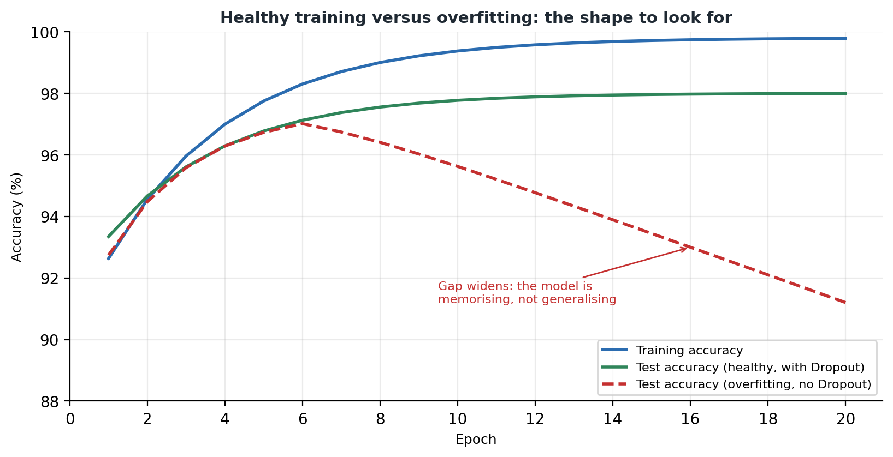
Diagram 7. What overfitting looks like on a graph: the two lines pull apart.
Look for the shape, not the exact numbers. When the training line keeps climbing while the test line flattens or turns down, the model has stopped learning the problem and started learning the answers. Dropout, more data, and stopping earlier are the usual fixes. This project uses dropout.

11.3 If your accuracy looks low
Check | Why
Did Step 4 actually run? | Feeding raw 0 to 255 values in makes training much worse. This is the most common cause.
Did you run every cell from the top, in order? | A notebook remembers what you ran. Out of order, anything can happen.
Did Step 7 finish before you ran Step 8? | That is why the notebook prints a reminder.
Is epochs still 5? | Too few epochs and it has not finished learning.
Did you restart the kernel part way through? | All variables are lost. Run everything again from the top.

11.4 What one accuracy number hides
A single percentage is a summary, and summaries lose detail. None of this is in the project, and all of it is worth knowing.
- Which digits it gets wrong. Mistakes are not spread evenly. 4 and 9, or 3 and 5, cause more than their share.
- How confident it was when it was wrong. Being wrong at 35 percent confidence is reasonable behaviour. Being wrong at 99 percent confidence is not, and accuracy alone cannot tell you which is happening.
- How it handles input unlike the training data. Section 13 shows you this directly with the drawing canvas.
- Whether the categories are balanced. MNIST is fairly even, so accuracy is a fair summary here. On uneven data a model can score highly while never predicting the rare category at all.
In short
Test on data the model has never seen. That is the only honest score.
Training and test scores close together is healthy. A big gap means overfitting.
Per-digit accuracy and per-job accuracy are different. Multiply the digits together.
Check you understood
1. Why is the test set never used during training?
2. A model scores 99 percent on training and 80 percent on test. What is wrong and what would you try?
3. If each digit is right 98 percent of the time, roughly how often is a four digit number entirely correct?

12. Making predictions
Key words in this section
Prediction: the model's answer for one input.
Confidence: how sure the model is, given as a number between 0 and 1.
argmax: finds the position of the biggest number in a list.
predictions = model.predict(x_test)
print(np.round(predictions[0], 2))
predicted_digit = np.argmax(predictions[0])
model.predict gives back ten numbers for every image. For 10,000 test images that is 10,000 sets of ten. Those ten numbers are the softmax output from section 8.7.
np.argmax turns those ten numbers into one answer by finding which position holds the biggest one. Position 7 means the answer is 7.
That the position happens to equal the digit is lucky for this project, because the categories are the numbers 0 to 9 in order. In another classifier, position 3 might mean cat, and you would need a lookup list. Do not assume it always works out this neatly.

12.1 Reading the ten numbers
[0.01, 0.00, 0.02, 0.01, 0.00, 0.00, 0.00, 0.94, 0.00, 0.02]
Reading this from left to right, position 0 holds 0.01, position 1 holds 0.00, and so on. The biggest is 0.94 at position 7. So the model thinks this is a 7, and it is 94 percent confident. The leftover confidence is scattered thinly across a few other digits.
Get into the habit of looking at all ten numbers rather than just the winner. A right answer at 0.94 and a right answer at 0.34 with a close second place are very different situations, even though both count as correct. In a real system, this is exactly how you would decide which cases to send to a human.

12.2 The three ways the project shows results
What it shows | Step | Why it is there
The ten raw numbers printed out | 9 | Makes it obvious that the model outputs a spread of confidence, not a single answer.
A bar chart of the ten numbers next to the picture | 9b | Easier to read. A tall lone bar means certainty. Several similar bars mean it is genuinely unsure.
A grid of ten pictures labelled green or red | 10 | A quick scan for mistakes, and a feel for which digits go wrong.
The three views go from exact but hard to read, through easy to interpret, to quick but shallow. Picking the right level of detail for the question you are asking is a skill that applies well beyond this project.

13. The drawing canvas
Key words in this section
Preprocessing: getting input into the same form as the training data.
Online learning: updating a trained model from new examples one at a time.
Catastrophic forgetting: a model losing what it knew after being retrained on a few examples.
Step 11 is the part that makes this project different from every other MNIST tutorial. It gives you a 280 by 280 canvas to draw on with the mouse, and tests the model on your handwriting instead of on more MNIST pictures.
This is where the project stops being an exercise and becomes an experiment. That 98 percent was measured on pictures from the same source as the training pictures. Your drawing comes from a completely different source: you, with a mouse, on a screen. The difference between those two scores is one of the most useful things in the whole project.

13.1 How the canvas is built
- ipycanvas provides the Canvas widget. It is created with sync_image_data=True, which is what lets Python read back what you drew. Without that flag the drawing only exists in the browser.
- The canvas is filled black and the pen is set to white, with a line width of 20 and rounded ends, to match how MNIST digits look.
- It is 280 by 280, exactly ten times the size of an MNIST image. Big enough to draw on with a mouse, and it shrinks down neatly.
- Three handlers track the mouse: one for pressing the button down, one for moving, one for letting go. A true or false variable remembers whether you are currently drawing.
- ipywidgets provides the Predict, Clear, Yes correct and No wrong buttons, the digit dropdown, and two output areas: one for the prediction and one for the feedback.

13.2 Turning a drawing into something the model can read
You cannot hand a drawing straight to the model. It has to be changed until it matches the training pictures. This function is probably the most instructive code in the project.
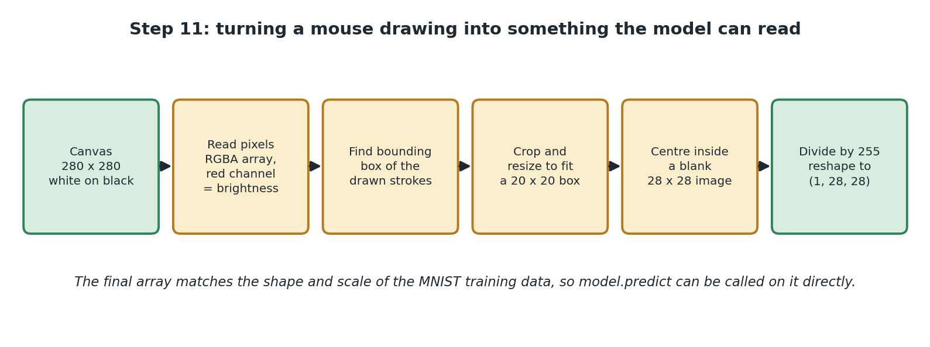
Diagram 8. The six stages that turn your drawing into model input.
Stage | The code | Why it is needed
Read the canvas | canvas.get_image_data() | Gives back four numbers per pixel: red, green, blue and transparency.
Keep only brightness | image_data[:, :, 0] | The drawing is white on black, so red, green and blue are all the same. Taking just the first one gives brightness and throws away two copies.
Find where the ink is | np.any(brightness > 0, ...) | Works out which rows and columns contain any ink, which gives a box around your drawing.
Handle an empty canvas | if not drawn_rows.any(): return None | Stops it crashing if you press Predict without drawing. It prints 'Draw a digit first!' instead.
Crop and shrink | digit.thumbnail((20, 20)) | Cuts away the empty space, then shrinks the drawing to fit a 20 by 20 box without squashing it.
Centre it | canvas_28.paste(digit, ...) | Puts the 20 by 20 drawing in the middle of a blank 28 by 28 black square, leaving a border like MNIST has.
Scale the numbers | np.array(canvas_28) / 255.0 | Exactly the same division by 255 as Step 4 did to the training data.
Wrap it up | reshape(1, 28, 28) | predict expects a group of images, so one image becomes a group of one.

13.3 The most useful lesson in the project
Cropping to 20 by 20 and centring in a 28 by 28 square is not tidying up. It is essential.
MNIST digits are all a similar size and sit in the middle with a border. So the model's 100,480 input weights are tuned to expect ink in the middle of the picture, at roughly that size. It has never seen anything else.
Skip the centring and your predictions get noticeably worse, even when your drawing is perfectly clear to a human eye. The model is not confused the way a person would be confused. It is simply being asked about a part of its input it has no experience of, and its answers there are close to random.
In short
Whatever you did to the training data, you must do exactly the same to anything you show the model later.
This is called training and serving skew. It causes more disappointing real world results than bad models do.

13.4 Teaching the model when it is wrong
After each prediction you are asked if it was right. Click No, wrong and you get a dropdown of the ten digits and a Teach the model button. That button runs this.
correct_label = np.array([digit_picker.value])
model.fit(last_drawn_image.reshape(1, 28, 28), correct_label,
epochs=3, verbose=0)
This trains the model on one single example, three times over, using the answer you gave. It nudges the weights so that drawing is more likely to be read correctly next time. The notebook calls this a demonstration of online learning: updating a model that has already been trained, rather than starting again.

Why it works
Nothing about training requires a big dataset. model.fit does exactly the same four stage loop on one image that it does on 60,000. The weights move in the direction that reduces the error on that one image.

Why you should not trust it
For exactly the same reason. The adjustment is aimed at getting your one drawing right, with nothing pulling in the other direction on behalf of the other 60,000. Do it enough times and the model drifts towards your handwriting and gets worse at everything else. This is called catastrophic forgetting, and it is a genuine unsolved problem, not a flaw in this code.
The project is honest about this, calling it a fun demo rather than a real training strategy. There is a bigger point underneath it too: a system that updates itself whenever a user says it is wrong can very easily turn into a system that agrees with the user instead of a system that is correct.
If you wanted to do this properly, you would collect corrections up over time and then retrain on the original data plus the corrections together, so the new examples have influence without taking over.
Check you understood
1. Why is the canvas black with a white pen rather than the other way round?
2. Why does the code crop and centre your drawing instead of just shrinking the whole canvas?
3. What is catastrophic forgetting, and how could you avoid it?

14. Saving the trained model
model.save("handwritten_digit_model.keras")

# To load it again later:
# model = tf.keras.models.load_model("handwritten_digit_model.keras")
Training takes time and effort. Saving the model means you never have to repeat it. The .keras file is a zip archive holding four things.
What is inside | What it is | Why you need it
The structure | The layers from Step 5 and how they connect. | Without it there is nothing to load the numbers into.
The learned numbers | All 101,770 weights and biases. | This is the knowledge the model gained. This is the model.
The optimizer's state | What adam had learned about how to adjust each weight. | Lets you carry on training later from where you stopped.
The compile settings | The loss and metric from Step 6. | So you can test or train it again without setting them up once more.

14.1 File formats
.keras is the current recommended format. You may also see .h5 in older tutorials. It stores much the same thing and is being phased out, so know what it is if you meet it but use .keras for new work.
The project's .gitignore excludes *.keras, so the file stays on your machine and is never uploaded. That is sensible for a teaching project. In real work, models are usually versioned deliberately, so you can always tell which model came from which code.
One last point the notebook makes: the file is only data. It is not a program. To use it you still need TensorFlow installed.

15. Bonus: watching backpropagation happen
Key words in this section
Gradient: a number saying which way to nudge a weight, and how much difference that weight makes.
Chain rule: the piece of calculus that lets you work out an effect through a chain of steps.
tf.GradientTape: TensorFlow's tool for recording calculations so they can be replayed backwards.
Backpropagation: the process of working out a gradient for every weight in the network.
Back in section 10.1 you were told that step three of the training loop works out how much each weight contributed to the error, and that TensorFlow does it for you. That was true, and it was also a bit of a cop-out. It is the one part of training that stays completely hidden.
This bonus section in the notebook opens it up. It is genuinely worth working through, because backpropagation has a reputation for being impenetrable maths, and it turns out to be something you can check by hand in about four lines.

15.1 What a gradient actually is
Start with the word, because it sounds worse than it is. A gradient is a slope. If you have a weight, and you want to know what happens to the loss when you nudge that weight slightly, the gradient is the answer. It tells you two things at once:
- The sign, positive or negative, tells you which direction to move. If increasing the weight increases the loss, you want to go the other way.
- The size tells you how much this particular weight matters right now. A gradient near zero means nudging it would barely change anything. A big one means this weight has real influence.
There is one gradient per weight. This project has 101,770 weights, so every single training step produces 101,770 gradients. The optimizer takes that list and uses it to decide how far to move each one. That is the whole of training in a sentence.

15.2 Recording the sum so you can run it backwards
The tool TensorFlow gives you is tf.GradientTape, and the name is a decent clue. Any calculation you do inside a tape block gets written down as it happens. Afterwards you can ask the tape to play the recording backwards, working out the slope at each step as it goes. That backwards replay is, literally, what backpropagation means.
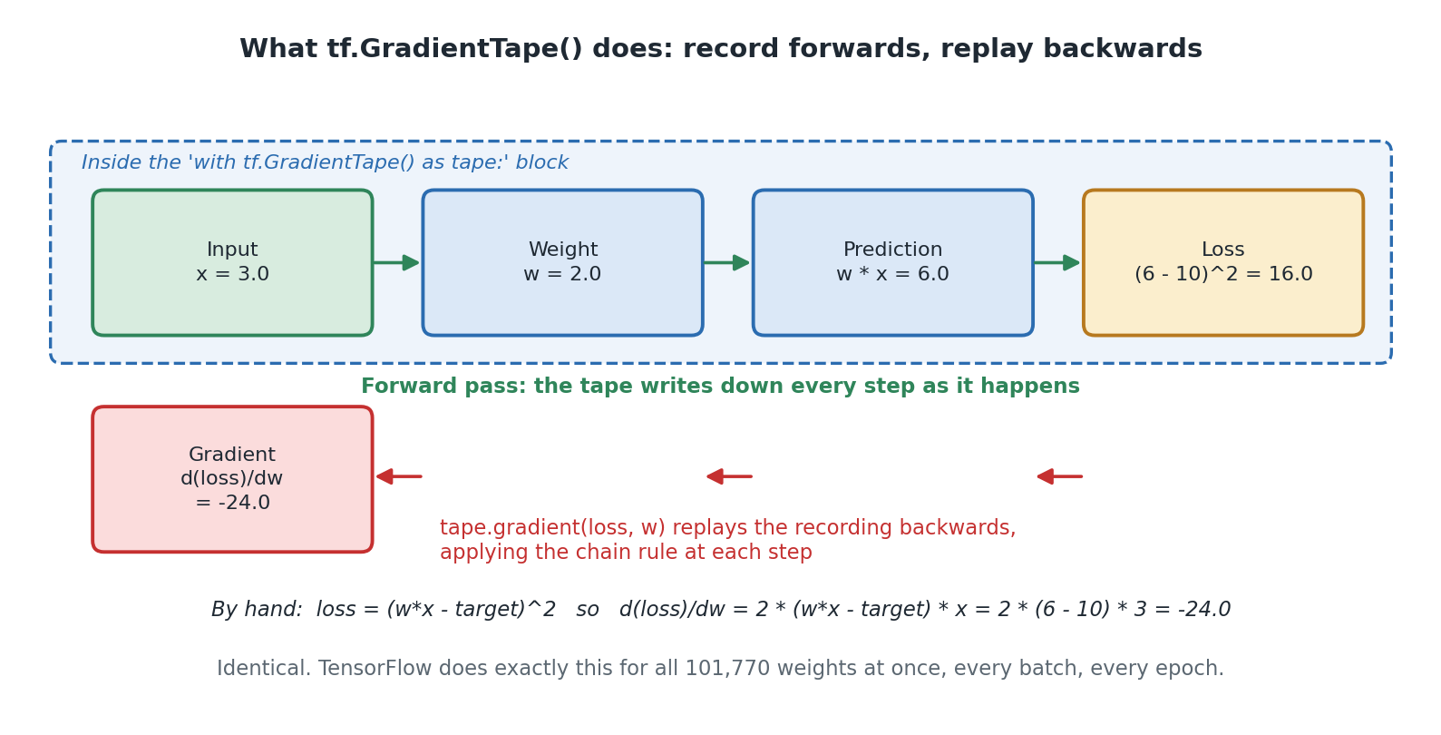
Diagram 9. The tape records the forward pass, then replays it backwards to produce a gradient.

15.3 The toy example, and checking it by hand
The notebook starts as small as it is possible to start: one input, one weight, one multiplication. No layers, no images, nothing hidden. Small enough that you can do the maths yourself and compare.
x = tf.constant(3.0) # a fixed input
target = tf.constant(10.0) # what we wish the prediction was
w = tf.Variable(2.0) # our one and only weight

with tf.GradientTape() as tape:
prediction = w * x # forward pass
loss = (prediction - target) ** 2 # how wrong were we?

gradient = tape.gradient(loss, w) # backward pass
Follow the numbers. The prediction is 2 times 3, which is 6. We wanted 10, so we are 4 out. Squaring that gives a loss of 16.
Now the question backpropagation answers: if we nudged w up slightly, would the loss go up or down, and by how much? The notebook works it out by hand alongside TensorFlow's answer.
# loss = (w*x - target)^2
# d(loss)/dw = 2 * (w*x - target) * x
# = 2 * (6 - 10) * 3
# = -24.0
Both numbers come out at exactly -24.0. Not close, exactly. The notebook makes the point sharply: TensorFlow did not guess, look anything up or approximate. It mechanically applied the same chain rule you would use with a pen, just automatically.
The sign tells you the loss falls as w increases, which makes sense because our prediction of 6 is too low and raising w would raise it. The size, 24, says this weight matters a lot right now. Both of those are exactly what the optimizer needs.
If the calculus is unfamiliar, do not let it stop you. The point of this cell is not that you can differentiate a squared bracket. It is that the mysterious step inside training turns out to be a small, checkable piece of arithmetic, done many times over.

15.4 The same thing on the real model
Having proved the mechanism on one weight, the notebook runs the identical technique on the actual trained model. There are 101,770 weights instead of one, and the calculation chains through four layers instead of a single multiplication, but nothing else changes.
sample_images = x_train[:32]
sample_labels = y_train[:32]

with tf.GradientTape() as tape:
predictions_sample = model(sample_images, training=True)
loss_value = tf.keras.losses.sparse_categorical_crossentropy(
sample_labels, predictions_sample)
loss_value = tf.reduce_mean(loss_value)

gradients = tape.gradient(loss_value, model.trainable_variables)
Notice that this is one real batch of 32 images, the same size the training loop uses. So this cell is doing precisely what happens 1,875 times per epoch inside model.fit, just where you can see it.
The gradient matrix comes back the same shape as the weight matrix it belongs to. One gradient per weight, no exceptions. That is worth pausing on, because it is what makes the whole thing work: nothing is approximated, grouped or skipped.

15.5 The zero gradients, and why they are not a bug
This is the best bit of the section, and it ties back to things covered much earlier in this guide.
The notebook prints gradient values for pixel 400, which sits roughly in the middle of the image, and gets back a spread of real numbers. It then invites you to change 400 to 0 and re-run. You get back exactly zero. Not very small. Exactly zero.
The reason is lovely. Pixel 0 is a corner of the image, and section 6.4 established that MNIST digits are centred with black borders. So that pixel is 0 in essentially every training image. A weight that only ever gets multiplied by zero cannot possibly affect the loss, no matter what value it takes. Its gradient is therefore exactly zero, and the optimizer correctly leaves it alone.
In other words, the network has worked out for itself that there is nothing to learn about the corners of the picture. Nobody told it. It falls out of the arithmetic.
This is also a neat illustration of something from section 8.2. Weights near zero mean the neuron does not care about that input. Here you can see the mechanism that makes it so.

15.6 Applying one real update
The last cell closes the loop by taking the gradients just calculated and applying one genuine optimizer step, then printing the same weight before and after.
original_weights = model.get_weights() # so we can undo this

weight_before = first_layer_weights.numpy()[400, 0]
model.optimizer.apply_gradients(zip(gradients, model.trainable_variables))
weight_after = model.trainable_variables[0].numpy()[400, 0]

model.set_weights(original_weights) # put it back
The change you see printed is small, which is exactly right. Section 10.3 explained that the network needs many passes precisely because each adjustment is deliberately tiny. Here is one of those tiny adjustments, measured.
Note the save and restore either side. The cell deliberately puts the model back exactly as it was, so running the demonstration does not quietly alter the model everything above it depends on. That is good practice worth pointing out in its own right: a demonstration that changes shared state is a bug waiting to surface three cells later.

15.7 Why this section is worth your time
You can build working models without ever reading this. Plenty of people do. But there are two solid reasons to spend twenty minutes here.
- It removes the magic. Training stops being something that mysteriously happens inside fit and becomes a mechanism you have watched work, step by step, on numbers you checked yourself.
- It makes the failure modes make sense. Once you have seen that training is just repeated small steps down a slope, it becomes obvious why the learning rate matters, why a gradient of zero means nothing gets learned, and why the process can settle somewhere mediocre.
In short
A gradient is a slope: which way to nudge a weight, and how much that weight matters.
tf.GradientTape records the forward calculation so it can be replayed backwards. That replay is backpropagation.
The notebook checks TensorFlow's gradient against hand-worked calculus and gets an exact match.
Corner pixels give gradients of exactly zero, because they are always zero in the training data.
Check you understood
1. What two pieces of information does a single gradient give you?
2. Why does the gradient for a corner pixel come out as exactly zero rather than very small?
3. Why does the last cell save the weights before applying the update and restore them afterwards?

16. A better design: convolutional networks
Key words in this section
Convolution: sliding a small filter across an image to look for a pattern.
Filter: a small grid of learned numbers that detects one feature, such as an edge.
Pooling: shrinking a grid by keeping only the strongest values.
The notebook ends with a runnable convolutional model, plus a list of exactly which cells you would change to convert the whole notebook to use one. The bonus cell stands on its own, so you can run it and compare without breaking the working version above it. That is a good habit to copy.

16.1 The problem being fixed
Section 7.3 showed that flattening throws away which pixels were next to each other. That causes two problems.
- It cannot reuse what it learns. If it learns to spot a horizontal stroke in the top left corner, that knowledge does nothing for the same stroke in the top right. It has to learn each position separately.
- It does not scale. 784 pixels into 128 neurons needs 100,480 numbers. An ordinary 256 by 256 colour photo has 196,608 pixels, which would need over 25 million numbers for the same first layer.

16.2 What a convolution does
Picture a small window, 3 pixels by 3 pixels, sliding across the image one step at a time. At each position it looks at the 9 pixels underneath it, multiplies them by 9 learned numbers, adds them up, and writes the answer into a new grid.
Crucially, it uses the same 9 numbers at every position. That is the whole idea, and it fixes both problems at once.
- Because the same window is used everywhere, a pattern learned in one place gets found everywhere.
- Because the window only has 9 numbers no matter how big the image is, the count of learned numbers no longer grows with the picture size.
One filter learns one small feature: an edge at a particular angle, a corner, a short curve. Conv2D(32, kernel_size=3) means 32 filters are learned at once, so you get 32 new grids, each showing where its feature was found. The second convolutional layer, with 64 filters, then looks for combinations of those features. That is how the network builds up from edges to loops to whole digits.

16.3 What pooling does
MaxPooling2D(pool_size=2) chops the grid into 2 by 2 squares and keeps only the biggest number in each. This halves the width and height, which cuts the work for later layers. It also adds a little tolerance for position: a feature that moves by one pixel usually still lands in the same square.

16.4 The bonus model
x_train_cnn = x_train.reshape(-1, 28, 28, 1)
x_test_cnn = x_test.reshape(-1, 28, 28, 1)

cnn_model = tf.keras.models.Sequential([
tf.keras.layers.Input(shape=(28, 28, 1)),
tf.keras.layers.Conv2D(32, kernel_size=3, activation="relu"),
tf.keras.layers.MaxPooling2D(pool_size=2),
tf.keras.layers.Conv2D(64, kernel_size=3, activation="relu"),
tf.keras.layers.MaxPooling2D(pool_size=2),
tf.keras.layers.Flatten(),
tf.keras.layers.Dense(64, activation="relu"),
tf.keras.layers.Dropout(0.3),
tf.keras.layers.Dense(10, activation="softmax")
])
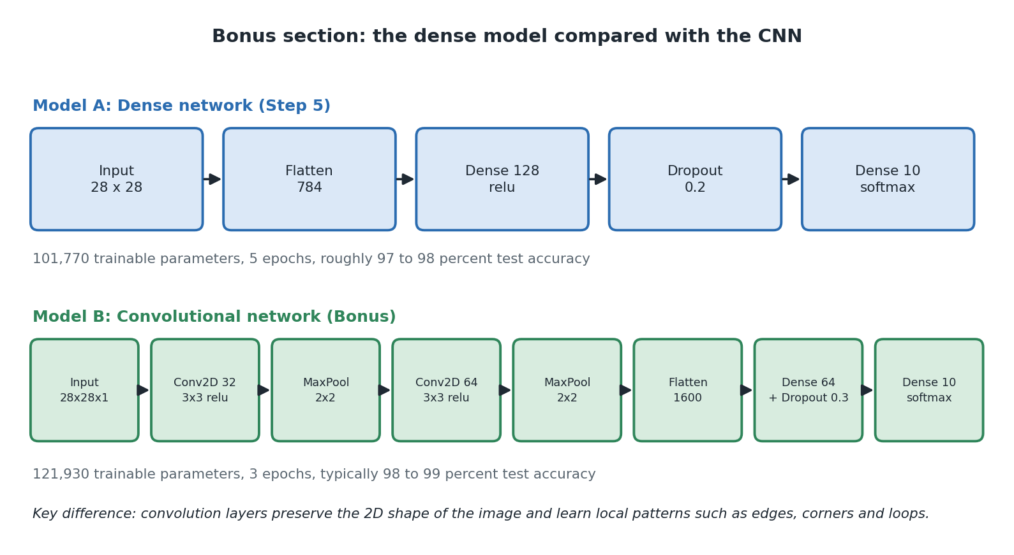
Diagram 10. The two models side by side.

16.5 Following the sizes through
This table explains where the number 1600 comes from, which is not obvious at first glance.
Layer | Grid size after it | Numbers learned | Working
Input | 28 x 28 x 1 | 0 | One shade-of-grey channel.
Conv2D 32, 3x3 | 26 x 26 x 32 | 320 | A 3 by 3 window loses one pixel at each edge. 32 filters x 9 numbers x 1 channel, plus 32 biases.
MaxPooling 2x2 | 13 x 13 x 32 | 0 | Halves both sides.
Conv2D 64, 3x3 | 11 x 11 x 64 | 18,496 | 64 filters x 9 numbers x 32 incoming channels, plus 64 biases.
MaxPooling 2x2 | 5 x 5 x 64 | 0 | 13 halved, rounded down to 5.
Flatten | 1600 | 0 | 5 x 5 x 64 = 1600.
Dense 64 | 64 | 102,464 | 1600 x 64, plus 64 biases.
Dropout 0.3 | 64 | 0 | A behaviour only.
Dense 10 | 10 | 650 | 64 x 10, plus 10 biases.
Total |  | 121,930

16.6 Comparing the two models
 | Dense model | CNN
Shape of the data | (images, 28, 28) | (images, 28, 28, 1). The extra 1 is the colour channel: 1 for grey, 3 for colour.
First layers | Flatten straight away | Conv2D and MaxPooling pairs, keeping the grid shape
Where Flatten goes | First | Only just before the final Dense layers
Dropout | 0.2 | 0.3
Epochs | 5 | 3, because each epoch does more work
Compile settings | adam, sparse crossentropy, accuracy | Exactly the same. Only the layers changed.
Numbers learned | 101,770 | 121,930, about 20 percent more
Typical test accuracy | 97 to 98 percent | 98 to 99 percent
Two things worth noticing. The compile settings do not change, which shows that the optimizer and loss follow from the type of problem, not from the design of the network. And the CNN does better in fewer epochs with only 20 percent more numbers. The improvement comes from a better design, not from being bigger. That is a good antidote to the assumption that bigger always wins.
Also notice what going from 98 to 99 percent means: it halves the number of mistakes. Each further step costs much more effort than the last one. That is normal in this field.

17. Where this is used in the real world
Reading single digits sounds narrow until you notice how much of the world is numbers written on paper. This section is background, not part of the project, and it is what makes the project worth doing.

17.1 Jobs this leads directly to
Use | What it does | What would need to change
Sorting post | Reads handwritten postcodes on envelopes so machines can route the mail. This was the original reason MNIST exists. | Find the postcode on the envelope, split it into separate characters, and handle letters as well as digits.
Processing cheques | Reads the handwritten amount on a bank cheque. | Much higher accuracy needed, plus a rule that anything uncertain goes to a person, plus a cross check between the written and numeric amounts.
Digitising forms | Pulls handwritten numbers out of boxes on paper forms, such as surveys or medical forms. | Find the boxes using a known template. Boxed forms are designed that way to make this easier.
Reading meters | Reads a gas or electricity meter from a phone photo. | Cope with angles, glare, blur and digits caught halfway between numbers. Much harder than clean scans.
Number plates | Reads vehicle registrations from camera footage. | Find the plate first, correct for angle and blur, then read a mix of letters and numbers.

17.2 The step this project does not take
Every use above needs something this project does not do: real pictures contain more than one symbol, and you do not know where they are.
- Classification answers 'what is this?' when the thing has already been cut out for you. That is what this project does.
- Detection answers 'where are the things?'. Segmentation separates them from each other and the background. Neither is in this project.
This is worth knowing because it corrects a common assumption. If you get 98 percent on MNIST it is tempting to think reading a page of handwriting is nearly solved. Recognising a single cut-out digit is the easy part. Finding, separating and ordering the digits is where most of the difficulty actually lives.

17.3 The same recipe elsewhere
Take away the digits and this project is a template: prepare the data, stack some layers, choose a loss, train, test on held back data, save. The notebook's own summary makes this point, noting the same steps apply whether you are recognising digits, filtering spam, or predicting house prices.
Field | Input | Output | What carries over
Medical scans | An X-ray or scan | A category, or an area of interest | The whole recipe. The stakes change how you handle uncertainty.
Factory quality control | A photo of a part on a production line | Pass, fail, or type of fault | Same structure. Usually far fewer examples to learn from.
Sorting documents | A scanned page | Invoice, contract, letter | Same kind of network, applied to the layout of a page.
Voice commands | A short sound clip turned into a picture of its frequencies | Which word was said | That picture is an image, so the same models work.

17.4 When not to use a neural network
A balanced view matters here. Neural networks are not the answer to everything, and it is easy to over-apply them after one successful run.
- When simple rules genuinely work. Checking a postcode is in the right format is a pattern match, not a model. Do not learn what you can just specify.
- When you have very little labelled data. This project has 60,000 examples. With 60, something simpler will usually beat a neural network.
- When you must be able to explain the decision. 101,770 numbers are not an explanation. In regulated work this can rule the approach out no matter how accurate it is.
- When mistakes are unacceptable rather than merely annoying. No model gets 100 percent. If the process cannot tolerate any error at all, it needs a person in the loop by design.
- When something simpler is good enough. A much simpler method reaches about 92 percent on MNIST. If 92 is fine, the extra complexity costs you and buys you nothing.

18. Limitations and risks
None of this is criticism. These are the expected properties of a teaching project. Knowing about them is what turns the project into an education.

18.1 It cannot say 'I do not know'
Softmax always produces ten numbers that add up to 1. Draw a letter, a squiggle or a smiley face on the canvas and you will still get a digit back, sometimes confidently. There is no eleventh output meaning not a digit, because the model was never shown anything that was not a digit.
This is a real issue in working systems. The usual answers are: refuse anything below a confidence threshold, add an 'other' category and train it on negative examples, or run a separate check first to decide whether the input is even relevant.

18.2 Confidence is not the same as being right
A softmax output of 0.94 means 'this is what the sums produced', not 'there is a 94 percent chance this is correct'. Networks trained this way are often overconfident, especially on input unlike anything they were trained on. The drawing canvas shows this directly: unusual handwriting often produces a wrong answer with high confidence.
This matters most in systems that send uncertain cases to a human, because the cases that most need checking are exactly the ones most likely to look confident.

18.3 The world changes and the model does not notice
The model works well on data that looks like its training data and gets worse on anything else, with no warning at all. MNIST came from a particular group of people at a particular time. Digits are written differently elsewhere: the crossed seven common in Europe, the one with a long upstroke that looks like a seven, the open four.
In a live system this shows up as something that worked at launch and quietly gets worse. You cannot spot it from the original test score, which is why real systems watch their live input rather than trusting a number measured once.

18.4 There is no validation set
The project trains on one set and tests on another, with nothing in between. That is fine here, because no decisions are made based on the test result. In real work, if you use the test set to choose between designs, information leaks out of it and your final score becomes flattering. The usual fix is three sets: one to train, one to make decisions with, and one used only once at the very end.
Keras supports this directly with validation_split in model.fit. Adding it is a natural extension and would let you plot both curves from Diagram 7 with no extra work.

18.5 Data and privacy
Not an issue for MNIST, which is a long established public research dataset. It becomes one the moment you extend the project with your own data. Handwriting is personal, scanned documents often contain personal details, and in some cases a trained model can leak information about what it was trained on. If you move on to real data, think about permission, storage and access before you think about the model.

19. Things to try
Each of these uses the project as it is, or a small change to it. Predict what will happen before you run it, then check whether you were right. That is where the learning is.
Try this | It shows you | What should happen
Comment out the two lines in Step 4, restart the kernel and retrain. | Normalisation | Accuracy climbs more slowly and ends lower. It still learns, which is the interesting bit.
Change the hidden layer from 128 to 16, then to 512. | Network size | 16 does noticeably worse. 512 gains very little for a longer wait.
Set Dropout to 0.0 and train for 20 epochs, writing down both scores each epoch. | Overfitting | Training accuracy keeps climbing while test accuracy flattens or falls. You have just drawn Diagram 6 from real numbers.
Plot history.history['accuracy'] after training. | Reading training | Turns a column of numbers into a curve. Do this one before the previous one.
Add validation_split=0.1 to model.fit. | Validation sets | You get a second score each epoch, without needing any extra data.
Print all ten numbers for twenty test images instead of just the winner. | Confidence | Some correct answers arrive with low confidence, and 4 and 9 often come close together.
Find an image the model got wrong and display it. | Error analysis | Many mistakes are digits you would struggle with too.
Draw a small digit in the corner of the canvas. | Preprocessing | It still works, because the code crops and centres it. Then turn off the centring and try again.
Draw a letter on the canvas. | No 'I do not know' | You still get a digit back. Links straight to section 18.1.
Use Teach the model on one digit ten times, then re-run Step 8. | Catastrophic forgetting | Overall accuracy drops. An abstract risk made real in two minutes.
In the backpropagation bonus, change the pixel index from 400 to 0 and re-run. | Gradients | Every gradient comes back as exactly zero, because corner pixels are always black in MNIST. Explains itself once you see it.
In the same bonus, try indices near the centre such as 350 or 450, then near the edges such as 27 or 755. | Where learning happens | Central pixels give the largest and most varied gradients. Edges give zero or near zero.
Change the toy example's starting weight from 2.0 to 4.0 and work the gradient out by hand before running it. | Chain rule | The prediction becomes 12, which is now too high, so the gradient flips sign. Good test of whether you followed section 15.3.
Run the bonus CNN cell and compare with Step 8. | Design beats size | Better accuracy in fewer epochs with only 20 percent more numbers.
Change the CNN filters from 32 and 64 to 8 and 16. | Filters | Accuracy falls a little but stays respectable, and it trains much faster.

20. Test yourself
Try to answer each question before reading the answer underneath it.
Q1. Why does the input layer have exactly 784 values?
Because each picture is 28 by 28 pixels, and 28 times 28 is 784. It is decided by the data, not chosen. The Flatten layer turns the grid into that flat list.
Q2. What would happen if you removed every activation function?
The whole network would collapse into the equivalent of a single layer, no matter how many layers you added. It could only learn very simple relationships and would do much worse.
Q3. Why is softmax used on the last layer instead of relu?
Because the ten outputs need to work as percentages of confidence in ten options that cannot overlap. Softmax forces them between 0 and 1 and makes them add up to 1. relu would give unlimited values that do not work as confidence.
Q4. What is the difference between loss and accuracy?
Loss is a smooth measure of how wrong the answers were, and it is what training tries to reduce. Accuracy is the percentage correct, which is easy for people to read but changes in jumps, so it cannot guide the learning.
Q5. Why is the sparse version of the loss used here?
Because the MNIST labels are plain numbers like 7, rather than lists like [0,0,0,0,0,0,0,1,0,0]. The sparse version takes plain numbers directly.
Q6. A model gets 99 percent on training and 82 percent on test. What is wrong?
Overfitting. It has memorised the training pictures rather than learning general patterns. You could add or increase dropout, get more data, use a smaller network, or stop training earlier.
Q7. Why does Dropout show zero parameters?
Because it does not learn anything. It just randomly switches neurons off during training, and it is turned off completely when the model is predicting.
Q8. Why does the canvas code crop and centre your drawing?
Because MNIST digits are all a similar size and sit in the middle of the picture. The model has only ever seen digits like that, so anything you show it has to match.
Q9. How many times are the weights updated during training in this project?
60,000 images divided by batches of 32 gives 1,875 updates per epoch. Times 5 epochs, that is 9,375.
Q10. Why does a convolutional layer need fewer numbers than a dense layer?
Because the same small window of 9 numbers is reused at every position on the image, instead of learning a separate number for every pixel. The count depends on the size and number of filters, not on the size of the picture.
Q11. Someone wants to use this to read six digit reference numbers because it is 98 percent accurate. What do you say?
Per-digit accuracy multiplies across the whole number. 0.98 to the power of 6 is about 0.89, so around one number in nine would be wrong somewhere. It needs a confidence threshold with human checking, or a check digit, or a much better model.
Q12. Why can this model never tell you an input is not a digit?
Because softmax always spreads confidence across the ten digits it was trained on and they always add up to 1. There is no eleventh option, and it never saw any non-digits during training.

21. Glossary
Word | What it means here
Accuracy | The percentage of pictures the model got right.
Activation function | A simple function applied to a neuron's total, such as relu. It is what makes extra layers worth having.
adam | The method used to adjust the weights during training. It works well without tuning.
argmax | Finds the position of the biggest number in a list. Turns ten confidence numbers into one answer.
Backpropagation | Working backwards through the network to find how much each weight contributed to the error.
Batch | A group of images handled together before the weights are changed. 32 here.
Bias | One extra learned number added to a neuron's total, the same every time.
Catastrophic forgetting | Losing general skill after being retrained on just a few new examples.
Classification | Sorting an input into one of a fixed set of categories.
CNN | Convolutional neural network. Keeps the picture as a grid and slides small filters across it.
Convolution | Sliding a small window across a picture, looking for one particular pattern.
Dense layer | A layer where every neuron receives every value from the previous layer.
Dropout | Randomly switching off some neurons during training so the network does not rely on any one of them. Off during prediction.
Epoch | One complete pass through all the training images. 5 here.
Chain rule | The piece of calculus that works out an effect through a chain of steps. Backpropagation is this, applied automatically.
Filter | The small grid of learned numbers a convolution slides across the picture. 3 by 3 here.
Gradient | A slope. For one weight, it says which way to nudge it and how much that weight currently matters. One per weight.
GradientTape | TensorFlow's tool for recording a calculation so it can be replayed backwards to produce gradients.
Flatten | Turning a 28 by 28 grid into a list of 784 numbers. Learns nothing, and loses the layout.
Generalisation | Doing well on data the model has never seen. The thing you actually want.
Gradient descent | The downhill search that training uses to reduce the loss.
Hidden layer | A layer in the middle whose values you never look at. 128 neurons here.
Keras | The friendly interface inside TensorFlow that you actually type.
Label | The correct answer attached to a training example.
Learning rate | How big a step to take when adjusting weights.
Loss | One number saying how wrong the predictions were. Training tries to make it smaller.
Max pooling | Shrinking a grid by keeping only the biggest value in each small square.
MNIST | The dataset of 70,000 handwritten digit pictures used here.
Neuron | One small calculator inside a layer. Multiplies, adds, then applies an activation function.
Normalisation | Scaling numbers into a small consistent range, here by dividing pixels by 255.
Online learning | Updating a trained model from new examples instead of starting again.
Overfitting | Memorising the training data instead of learning general patterns.
Parameter | A learned weight or bias. This model has 101,770.
Pixel | One dot in a picture, stored as a brightness number.
relu | An activation function: keep positive numbers, turn negative ones into 0.
Sequential | A model where layers are stacked in a straight line.
softmax | Turns raw scores into confidence numbers between 0 and 1 that add up to 1.
Supervised learning | Learning from examples that come with the correct answers.
Tensor | A list of numbers with any number of dimensions.
Test set | Pictures kept back from training, used only to score the model. 10,000 here.
Training set | Pictures used to teach the model. 60,000 here.
Underfitting | Failing to learn the pattern at all. Both scores come out low.
Validation set | Extra data held back for making decisions, keeping the test set clean. Not used in this project.
Weight | A learned number saying how much one input matters to one neuron.

22. Quick reference

22.1 Commands
What it does | Command
Create the environment | python -m venv .venv
Turn it on, Windows | .venv\Scripts\activate
Turn it on, macOS or Linux | source .venv/bin/activate
Install the packages | pip install -r requirements.txt
Register the kernel | python -m ipykernel install --user --name=handwritten-digit-venv --display-name "Python (handwritten-digit-venv)"
Start Jupyter, Windows | .venv\Scripts\jupyter-lab.exe
Start Jupyter, macOS or Linux | .venv/bin/jupyter-lab
See what Jupyter servers are running | jupyter server list
Check your Python version | python --version

22.2 The code used in the project
Rather than a bare list, here is what each piece of code actually does, grouped by the job it belongs to. If you are trying to remember what something was for, this is the place to look.

Getting the data
tf.keras.datasets.mnist.load_data() fetches the MNIST dataset and hands it back already split into a training half and a test half. The first time you run it, TensorFlow downloads the files and caches them, so every run after that is instant. It returns a nested pair of pairs, which is why the line unpacking it looks a bit odd, and each of the four things you get back is a NumPy array. Other datasets sit alongside it under tf.keras.datasets and work the same way.

Describing the network
tf.keras.models.Sequential takes a list of layers and connects them in a straight line, each one feeding the next. It is the simplest of the ways Keras lets you define a model, and it covers a large share of real work. Note that it does not train anything or even allocate the weights until it knows the input shape, which is why the first item in the list matters.
tf.keras.layers.Input declares the shape of one example, without the batch dimension. Here that is (28, 28). It contains no neurons and learns nothing. Its whole job is to let Keras work out the sizes of everything downstream, which is what makes model.summary() able to report sensible numbers before you have trained anything.
tf.keras.layers.Flatten reshapes whatever it receives into a single flat list. A 28 by 28 grid becomes 784 values. It has no weights and does no arithmetic, it simply rearranges. You need it because a Dense layer expects a flat list, not a grid, and it costs you all the information about which pixels were next to each other.
tf.keras.layers.Dense(n, activation=...) is the workhorse. It creates n neurons, each of which receives every value from the previous layer, multiplies each one by its own learned weight, adds them all up, adds its own bias, and applies the activation function you named. This is where almost all the learned numbers in this project live. Give it activation="relu" for a hidden layer and activation="softmax" for the final layer of a classifier.
tf.keras.layers.Dropout(rate) randomly switches off that fraction of the previous layer's outputs, but only while training. At 0.2 it disables a fifth of them on each pass, choosing a different fifth every time. It learns nothing and holds no weights. It exists purely to stop the network leaning too heavily on any one neuron, which is what overfitting looks like from the inside.
tf.keras.layers.Conv2D(filters, kernel_size=...) appears only in the bonus section. It slides a small window, 3 by 3 here, across the image, and at every position multiplies what it sees by a set of learned numbers. Crucially it uses the same numbers at every position, so a pattern it learns to spot in one corner it can spot anywhere. Ask for 32 filters and it learns 32 different small patterns at once.
tf.keras.layers.MaxPooling2D(pool_size=...) shrinks a grid by dividing it into small squares and keeping only the largest value from each. With pool_size=2 it halves both the width and the height, which cuts the work for everything downstream and makes the network slightly less fussy about exactly where a feature sits.

Checking what you built
model.summary() prints a table of your layers with the output shape and the number of learned values for each, plus a total at the bottom. Get into the habit of reading it every time you change the architecture. It catches shape mistakes immediately, and the parameter counts tell you at a glance whether you have accidentally built something enormous.

Setting up and running training
model.compile(optimizer, loss, metrics) configures how learning will work, and does nothing else. Nothing visible happens when you run it. The optimizer decides how the weights get adjusted, the loss decides what counts as wrong, and the metrics are extra scores reported for you to read. You must call it before fit, and if you change it you need to call it again.
model.fit(x, y, epochs=...) is the one that actually trains. It runs the four stage loop from section 10.1 over and over, printing loss and accuracy after each epoch, and returns a history object holding those numbers so you can plot them afterwards. Two extra arguments are worth knowing: batch_size, which defaults to 32, and validation_split, which holds back a slice of your training data and scores against it every epoch. That second one is how you find the critical point discussed in section 10.3.
model.evaluate(x, y) runs the model over data you supply and returns the loss and the metrics, without changing a single weight. Dropout is switched off automatically. Give it your test set and you get the honest score. Give it your training set and you get a number that flatters you, which is only useful for comparing the two.

Using the trained model
model.predict(x) runs the model forward and returns its raw output. For this project that is ten numbers per image, adding up to 1, one confidence value per digit. It expects a batch, so if you have a single image you must reshape it to (1, 28, 28) first. That reshape catches nearly everybody the first time.
np.argmax(array) is NumPy rather than TensorFlow. It returns the position of the largest value in a list, which turns those ten confidence numbers into a single answer. It happens to give you the digit directly here because the categories are the numbers 0 to 9 in order. In a different problem you would need a lookup list to turn the position into a meaningful label.

Looking inside training
tf.GradientTape() is a context manager. Any TensorFlow calculation done inside its with block gets recorded, so that afterwards you can ask for the slope of one value with respect to another. You only need it when you want to see or control training yourself, because model.fit uses it internally on your behalf.
tape.gradient(loss, variables) is the backward pass. Hand it the loss you calculated inside the tape and the things you want gradients for, and it replays the recording backwards to produce one gradient per variable, in matching shapes. model.trainable_variables is the convenient way to name every weight and bias in the model at once.
model.optimizer.apply_gradients(zip(gradients, model.trainable_variables)) performs one real update, pairing each gradient with the weight it belongs to and letting the optimizer decide how far to move each one. This is exactly what happens inside fit, once per batch. Paired with model.get_weights() and model.set_weights(), you can apply an update, look at the effect and then put everything back as it was.

Saving and loading
model.save("name.keras") writes everything to one file: the architecture, all the learned weights, the optimizer's internal state and the compile settings. It is a zip archive underneath. The .keras extension is the current recommended format, replacing the older .h5 you will see in tutorials written a few years ago.
tf.keras.models.load_model(path) reads that file back and hands you a model you can immediately predict with, evaluate, or carry on training. Worth remembering that the file is only data, so whatever machine loads it still needs TensorFlow installed.

22.3 The numbers to remember
 | Value
MNIST images in total | 70,000
Used for training | 60,000
Held back for testing | 10,000
Size of each image | 28 by 28 pixels, greyscale
Numbers per image | 784
Hidden layer | 128 neurons, relu
Dropout | 0.2 (0.3 in the bonus CNN)
Output layer | 10 neurons, softmax
Numbers the model learns | 101,770 (121,930 for the CNN)
Epochs | 5 (3 for the CNN)
Batch size | 32
Weight updates during training | 9,375
Expected test accuracy | 97 to 98 percent (98 to 99 for the CNN)
Canvas size | 280 by 280 pixels, pen width 20

23. Where this information came from
Source | Used for
README.md | The tool list, installation and running instructions, troubleshooting, canvas advice, expected accuracy, and the notes on Windows and GPUs.
requirements.txt | The package list in section 3.1. Unchanged from the previous version of the repository.
.gitignore | The excluded files mentioned in sections 2.4 and 14.1. Carried over from the previous version of the repository.
handwritten_digit_recognition.ipynb | All the layer settings, epoch counts, prediction code, canvas code, saving code, the backpropagation bonus and the CNN bonus.

23.1 What has been added
The following is background added by this guide rather than taken from the project, so you know the difference: section 4.4 on types of problem, section 5.4 on tensors, section 5.6 on where models get deployed, section 6.5 on the limits of MNIST, section 11.4 on what accuracy hides, and sections 17 to 20 in full. The explanations in sections 7 to 16 are standard machine learning material, applied to this project's actual numbers.
The parameter counts in sections 8.8 and 16.5 were calculated from the layer definitions rather than copied from the notebook's output, because the notebook was not run during this analysis. Check them against a real run of model.summary() before quoting them.

